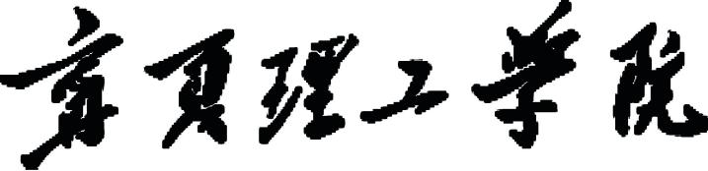



设计说明书

|  |  |
| --- | --- |
| 学院 | 计算机科学与工程学院 |
| 课程 | 面向对象程序设计 |
| 项目名称 | 诗词管理系统 |
| 班级 | 计科22101 |
| 学号 | 2205006224 |
| 姓名 | 苏一行 |
| 时间 | 2023-2024学年第二学期 |

目 录

1. 系统设计 3

1.1 总体设计 3

1.1.1管理员端 3

1.1.2用户端 4

1.2数据库设计 5

2.系统实现 6

2.1 实体类 6

2.1.1 用户实体类 6

2.1.2 管理员实体类 7

2.1.3诗词实体类 8

2.2 工具类 11

2.2.1数据库连接 11

2.2.2数据插入 11

2.2.3数据删除 14

2.2.4 数据查找 18

2.2.5 数据更新 32

2.3 功能实现 37

2.3.1登录功能实现 37

2.3.2 注册功能实现 43

2.3.3 用户端-诗词集锦功能实现 49

2.3.4 用户端-诗词检索功能的实现 57

2.3.5 用户端-我的收藏功能实现 62

2.3.6 用户端-个人面板的实现 66

2.3.7 管理端-诗词管理功能实现 73

2.3.8 管理端-用户管理的实现 85

3.2.9 管理端-添加管理员与个人面板 94

# 1. 系统设计

## 1.1 总体设计

本系统主要包括管理员端和客户端，主要包括收藏管理、用户管理、诗词管理、个人信息管理等功能。

### 1.1.1管理员端

（1）登录：管理员需登录系统后，才可操作系统。

（2）诗词管理：管理员可以对诗词进行增加、查找、删除、修改的操作，其中，查找功能包括多条件查找、精确查找以及模糊查找。

（3）用户管理：在用户注册后，管理员对用户进行管理。管理员可以修改用户信息、删除用户、添加用户，管理员可以查询所有用户信息，可以分别根据用户ID、用户名以及电话号码作出精确查询以及模糊查询。同时，在管理过程中，管理员可以选择是否展示用户密码。

（4）添加管理员：在该系统中，管理员有权限添加新的管理员。

（5）个人面板：管理员可以在该界面查看并修改个人信息、同时可以选择退出登录。

管理员端功能模块图如图1.1所示。

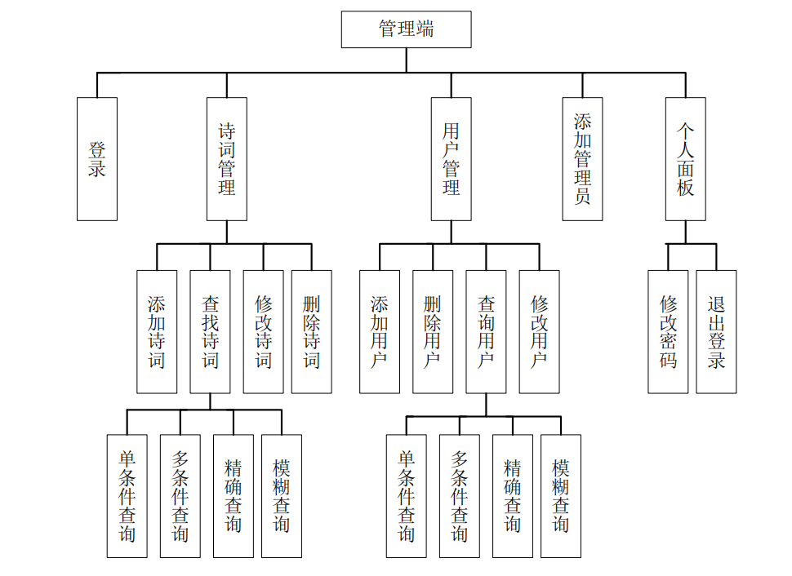

图1.1管理端功能模块图

### 1.1.2用户端

用户端包括以下功能：

（1）注册：用户输入个信信息进行注册。

（2）登录：用户需登录系统后，才可操作系统。

（3）诗词集锦： 用户可以在该界面浏览诗词，并将选中的诗词全文展示在最右侧面板上，同时可以选择是否要对该诗词进行收藏。

（4）诗词检索：用户可以诗词库中所有的诗词进行查看，并选择喜欢的进行收藏，其中查询方式包括单条件查找、多条件查找、模糊查找、精确查找。

（5）收藏管理：用户可以查阅所有自己已经收藏的诗词，并可以对诗词进行移除收藏，以及在收藏面板中尽显查询，其中查询方式包括单条件查找、多条件查找、模糊查找、精确查找。同时，用户可将收藏的诗词经筛选后批量导出为文本文件。

（6）个人面板：管理员可以在该界面查看并修改个人信息、同时可以选择退出登录。

用户端功能模块图如图1.2所示

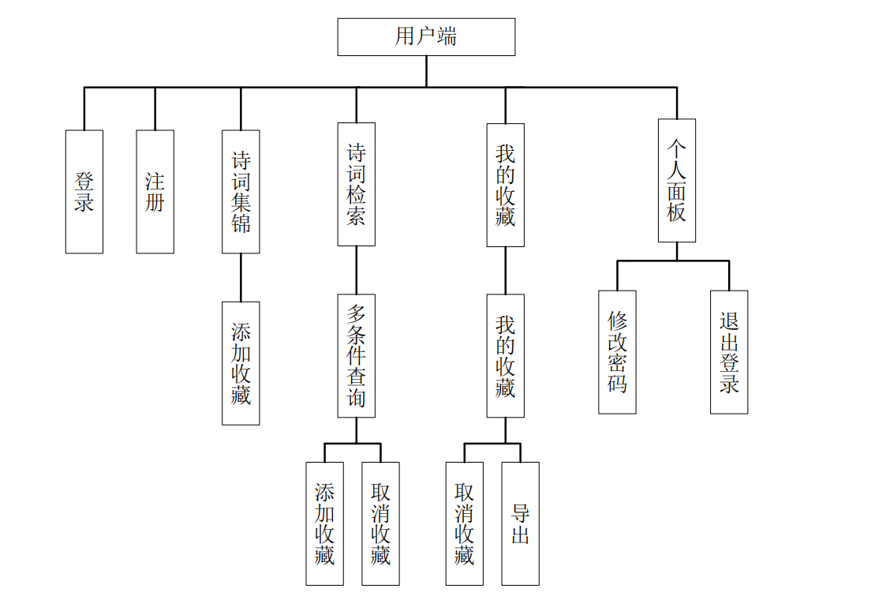

图1.2读者端功能模块图

## 1.2数据库设计

本系统所需的表如下：

（1）用户表（user）该表结构如表1.1所示。

表1.1 用户表

|  |  |  |  |  |
| --- | --- | --- | --- | --- |
| 字段 | 类型 | 是否为空 | 主键 | 中文描述 |
| user_id | INT | NOT NULL | PRIMARY KEY | 用户ID |
| user_account | CHAR(20) | NOT NULL | NO | 用户名 |
| user_password | CHAR(20) | NOT NULL | NO | 密码 |
| Telephone | CHAR(20) | NULL | NO | 联系电话 |

（2）管理员表（admin）该表结构如表1.2所示。

表1.2管理员表

|  |  |  |  |  |
| --- | --- | --- | --- | --- |
| 字段 | 类型 | 是否为空 | 主键 | 中文描述 |
| admin_id | INT | NOT NULL | PRIMARY KEY | 管理员ID |
| admin_account | CHAR(20) | NOT NULL | NO | 管理员账号 |
| admin_password | CHAR(20) | NOT NULL | NO | 密码 |
| admin_name | CHAR(20) | NULL | NO | 姓名 |
| Telephone | CHAR(20) | NULL | NO | 电话 |

（3）诗词表（poetry）该表结构如表1.3所示。

表1.3诗词表

|  |  |  |  |  |
| --- | --- | --- | --- | --- |
| 字段 | 类型 | 是否为空 | 主键 | 中文描述 |
| poetry_id | INT | NOT NULL | PRIMARY KEY | 诗词编号 |
| title | VARCHAR(20) | NULL | NO | 标题 |
| author | VARCHAR(20) | NULL | NO | 作者 |
| dynasty | CHAR(10) | NULL | NO | 作者朝代 |
| type | CHAR(10) | NULL | NO | 类别 |
| text | TEXT | NOT NULL | NO | 诗词正文 |

（4）诗词表（poetry）该表结构如表1.3所示。

表1.4收藏表

|  |  |  |  |  |
| --- | --- | --- | --- | --- |
| 字段 | 类型 | 是否为空 | 主键 | 中文描述 |
| user_id | INT | NOT NULL | PRIMARY KEY | 用户ID |
| Poetry_ID | INT | NOT NULL | PRIMARY KEY | 诗词编号 |

其中，在表1.1 1.2 1.3 中均设置了主键自增，表1.4的两个主键分别为表1.1与表1.2的外键。

# 2.系统实现

## 实体类

### 2.1.1 用户实体类

**package** pojo;  
  
**public class** User {  
 **private int** id;  
 **private** String name;  
 **private** String password;  
 **private** String telephone;  
 **private int** satrs;  
 **public** User(**int** id, String name, String password, String telephone, **int** satrs) {  
 **this**.id = id;  
 **this**.name = name;  
 **this**.password = password;  
 **this**.telephone = telephone;  
 **this**.satrs = satrs;  
 }  
   
 **public** User() {  
 }  
 **public int** getId() {  
 **return** id;  
 }  
 **public void** setId(**int** id) {  
 **this**.id = id;  
 }  
 **public** String getName() {  
 **return** name;  
 }  
 **public void** setName(String name) {  
 **this**.name = name;  
 }  
 **public** String getPassword() {  
 **return** password;  
 }  
 **public void** setPassword(String password) {  
 **this**.password = password;  
 }  
 **public** String getTelephone() {  
 **return** telephone;  
 }  
 **public void** setTelephone(String telephone) {  
 **this**.telephone = telephone;  
 }  
 **public int** getSatrs() {  
 **return** satrs;  
 }  
 **public void** setSatrs(**int** satrs) {  
 **this**.satrs = satrs;  
 }  
}

### 2.1.2 管理员实体类

**package** pojo;  
  
**import** database.DataSelece;  
  
**public class** Administrator {  
 **private int** id;  
 **private** String account;  
 **private** String password;  
 **private** String name;  
 **private** String telephone;  
  
 **public** Administrator(**int** id, String account, String password, String name, String telephone) {  
 **this**.id = id;  
 **this**.account = account;  
 **this**.password = password;  
 **this**.name = name;  
 **this**.telephone = telephone;  
 }  
 **public** Administrator() {}  
  
 **public int** getId() {  
 **return** id;  
 }  
 **public void** setId(**int** id) {  
 **this**.id = id;  
 }  
  
 **public** String getAccount() {  
 **return** account;  
 }  
  
 **public void** setAccount(String account) {  
 **this**.account = account;  
 }  
 **public** String getPassword() {  
 **return** password;  
 }  
 **public void** setPassword(String password) {  
 **this**.password = password;  
 }  
 **public** String getName() {  
 **return** name;  
 }  
 **public void** setName(String name) {  
 **this**.name = name;  
 }  
 **public** String getTelephone() {  
 **return** telephone;  
 }  
 **public void** setTelephone(String telephone) {  
 **this**.telephone = telephone;  
 }  
  
 **public static void** main(String[] args) {  
 Administrator administrator = DataSelece.findByAdminID(1);  
  
 **assert** administrator != **null**;  
 System.out.println(administrator.id);  
 System.out.println(administrator.account);  
 System.out.println(administrator.password);  
 System.out.println(administrator.telephone);  
 System.out.println(administrator.name);  
 }  
}

### 2.1.3诗词实体类

**package** pojo;  
**import** java.util.Map;  
**public class** Poetry {  
 **private int** poetry_id;  
 **private** String title;  
 **private** String author;  
 **private** String dynasty;  
 **private int** star;  
 **private** String type;  
 **private** String[] text;  
 **public** Poetry(**int** poetry_id, String title, String author, String dynasty, **int** star, String type, String text) {  
 **this**.poetry_id = poetry_id; *// Integer.parseInt(poetry_id);* **this**.title = title;  
 **this**.author = author;  
 **this**.dynasty = dynasty;  
 **this**.star = star; *// Integer.parseInt(star);* **this**.type = type;  
 **this**.text = toStrings(text);  
 }  
 **public** Poetry() {}  
 **private static** String[] toStrings(String text) {  
 *// 按句号为分隔符分割文本，并去除首尾空白后存入数组* String[] sentences = text.split(**"[。？?]"**);  
 *// 去除每个句子前后的空白符* **for** (**int** i = 0; i < sentences.length; i++) {  
 sentences[i] = sentences[i].trim() + **"。"**;  
 }  
 **return** sentences;  
 }  
 **public int** getPoetry_id() {  
 **return** poetry_id;  
 }  
 **public void** setPoetry_id(String poetry_id) {  
 **this**.poetry_id = Integer.parseInt(poetry_id);  
 }  
 **public** String getTitle() {  
 **return** title;  
 }  
 **public void** setTitle(String title) {  
 **this**.title = title;  
 }  
 **public** String getAuthor() {  
 **return** author;  
 }  
 **public void** setAuthor(String author) {  
 **this**.author = author;  
 }  
 **public** String getDynasty() {  
 **return** dynasty;  
 }  
 **public void** setDynasty(String dynasty) {  
 **this**.dynasty = dynasty;  
 }  
 **public int** getStar() {  
 **return** star;  
 }  
 **public void** setStar(String star) {  
 **this**.star = Integer.parseInt(star);  
 }  
 **public** String getType() {  
 **return** type;  
 }  
 **public void** setType(String type) {  
 **this**.type = type;  
 }  
 **public** String[] getText() {  
 **return** text;  
 }  
 **public void** setText(String text) {  
 **this**.text = toStrings(text);  
 }  
// debug  
 **public static void** main(String[] args) {  
 String text = **"明月几时有？把酒问青天。不知天上宫阙，今夕是何年。我欲乘风归去，又恐琼楼玉宇，高处不胜寒。起舞弄清影，何似在人间？(何似 一作：何时；又恐 一作：惟 / 唯恐)\n"** +  
 **"转朱阁，低绮户，照无眠。不应有恨，何事长向别时圆？人有悲欢离合，月有阴晴圆缺，此事古难全。但愿人长久，千里共婵娟。"**;  
  
 String[] strs = toStrings(text);  
 **for** (String s:strs) {  
 System.out.println(s);  
 }  
 }  
}

## 2.2 工具类

### 2.2.1数据库连接

**package** database;  
**import** java.sql.*;  
**public class** DataControl {  
 *// 打开数据库* **public static** Connection openData() **throws** SQLException {  
 Connection con = **null**;  
  
 String url = **"jdbc:mysql://127.0.0.1:3306/poetrydatabase?serverTimezone=UTC"**;  
 String username = **"root"**;  
 String password = **"123456"**;  
 con = DriverManager.getConnection(url, username, password);  
 **return** con;  
 }  
  
 *// 关闭数据库* **public static boolean** closeData(Connection con) {  
 **if** (con != **null**) {  
 **try** {  
 con.close();  
 System.out.println(**"Database connection closed successfully"**);  
 **return** con.isClosed();  
 } **catch** (SQLException e) {  
 System.err.println(**"Failed to close database connection: "** + e.getMessage());  
 }  
 }  
 **return false**; *// Connection was null or closing failed* }  
}

### 2.2.2数据插入

**package** database;  
**import** pojo.Poetry;  
**import** util.SystemConstants;  
**import** java.sql.Connection;  
**import** java.sql.DriverManager;  
**import** java.sql.PreparedStatement;  
**import** java.sql.SQLException;  
  
**public class** DataInsert {  
   
 *// 插入收藏的诗词的数据* **public static void** StarInsert(**int** poetryID) {  
 String query = **"INSERT INTO star_table (poetry_id, user_id) VALUES (?, ?)"**;  
 **try** (Connection con = DataControl.openData();  
 PreparedStatement pstmt = con.prepareStatement(query)) {  
 pstmt.setInt(1, poetryID);  
 pstmt.setInt(2, SystemConstants.currentID);  
 **int** rowsAffected = pstmt.executeUpdate();  
 **if** (rowsAffected > 0) {  
 System.out.println(**"Successfully inserted the star record."**);  
 } **else** {  
 System.out.println(**"Failed to insert the star record."**);  
 }  
 } **catch** (SQLException e) {  
 e.printStackTrace();  
 }  
 }  
  
 *// 插入新诗词* **public static void** PoetryInsert(String title,String author, String dynasty, String type, String text) {  
 **if** (title.isEmpty()) title = **"无题"**;  
 **if** (author.isEmpty()) author = **"佚名"**;  
 **if** (dynasty.isEmpty()) dynasty = **"不详"**;  
 **if** (type.isEmpty()) type = **"暂无归类"**;  
 String query = **"INSERT INTO poetry (title, author, dynasty, type, text) VALUES (?, ?, ?, ?, ?)"**;  
  
 **try** (Connection conn = DataControl.openData();  
 PreparedStatement stmt = conn.prepareStatement(query)) {  
  
 *// Set parameters* stmt.setString(1, title);  
 stmt.setString(2, author);  
 stmt.setString(3, dynasty);  
 stmt.setString(4, type);  
 stmt.setString(5, text);  
  
 *// Execute the query* stmt.executeUpdate();  
  
 System.out.println(**"Poetry inserted successfully!"**);  
  
 } **catch** (SQLException e) {  
 e.printStackTrace();  
 System.out.println(**"Failed to insert poetry."**);  
 }  
 }  
  
 *// 插入新用户* **public static boolean** UserInsert(String userAccount, String userPassword, String userTelephone) {  
 String query = **"INSERT INTO user (user_account, user_password, user_telephone) VALUES (?, ?, ?)"**;  
  
 **try** (Connection conn = DataControl.openData();  
 PreparedStatement stmt = conn.prepareStatement(query)) {  
  
 *// 设置参数* stmt.setString(1, userAccount);  
 stmt.setString(2, userPassword);  
 stmt.setString(3, userTelephone);  
  
 *// 执行查询* stmt.executeUpdate();  
  
 System.out.println(**"User inserted successfully!"**);  
  
 **return true**;  
  
 } **catch** (SQLException e) {  
 e.printStackTrace();  
 System.out.println(**"Failed to insert user."**);  
 **return false**;  
 }  
 }  
 *// 插入管理员* **public static boolean** AdminInsert(String adminAccount, String adminPassword, String adminName, String telephone) {  
 String query = **"INSERT INTO admin (admin_account, admin_password, admin_name, telephone) VALUES (?, ?, ?, ?)"**;  
  
 **try** (Connection conn = DataControl.openData();  
 PreparedStatement stmt = conn.prepareStatement(query)) {  
  
 *// 设置参数* stmt.setString(1, adminAccount);  
 stmt.setString(2, adminPassword);  
 stmt.setString(3, adminName);  
 stmt.setString(4, telephone);  
  
 *// 执行查询* stmt.executeUpdate();  
  
 System.out.println(**"Admin inserted successfully!"**);  
  
 **return true**;  
  
 } **catch** (SQLException e) {  
 e.printStackTrace();  
 System.out.println(**"Failed to insert admin."**);  
 **return false**;  
 }  
 }  
}

### 2.2.3数据删除

**public class** DataDelete {  
  
 *// 删除收藏的数据* **public static void** StarDelete(**int** poetryID) {  
 String deleteStar = **"DELETE FROM star_table WHERE poetry_id = ? AND user_id = ?"**;  
 **try** (Connection con = DataControl.openData();  
 PreparedStatement pstmt = con.prepareStatement(deleteStar)) {  
 pstmt.setInt(1, poetryID);  
 pstmt.setInt(2, SystemConstants.currentID);  
 **int** rowsAffected = pstmt.executeUpdate();  
 **if** (rowsAffected > 0) {  
 System.out.println(**"Successfully deleted the star record."**);  
 } **else** {  
 System.out.println(**"Failed to delete the star record."**);  
 }  
 } **catch** (SQLException e) {  
 System.out.println(**"Error occurred while deleting the star record: "** + e.getMessage());  
 e.printStackTrace();  
 }  
 }  
  
 *// 删除诗词* **public static void** PoetryDelete(**int** id) {  
 String query = **"DELETE FROM poetry WHERE poetry_id = ?"**;  
 Connection con = **null**;  
 PreparedStatement stmt = **null**;  
  
 **try** {  
 *// Open database connection* con = DataControl.openData();  
  
 *// Prepare the DELETE statement* stmt = con.prepareStatement(query);  
 stmt.setInt(1, id);  
  
 *// Execute the DELETE statement* **int** rowsAffected = stmt.executeUpdate();  
 **if** (rowsAffected > 0) {  
 System.out.println(**"Poetry with id "** + id + **" deleted successfully."**);  
 } **else** {  
 System.out.println(**"No poetry found with id "** + id);  
 }  
  
 } **catch** (SQLException e) {  
 System.err.println(**"SQL error: "** + e.getMessage());  
 } **finally** {  
 *// Close the statement and connection* **try** {  
 **if** (stmt != **null**) {  
 stmt.close();  
 }  
 } **catch** (SQLException e) {  
 System.err.println(**"Failed to close statement: "** + e.getMessage());  
 }  
  
 DataControl.closeData(con);  
 }  
 }  
 *// 删除用户* **public static void** UserDelete(**int** id) {  
 String query = **"DELETE FROM user WHERE user_id = ?"**;  
 Connection con = **null**;  
 PreparedStatement stmt = **null**;  
  
 **try** {  
 *// Open database connection* con = DataControl.openData();  
  
 *// User the DELETE statement* stmt = con.prepareStatement(query);  
 stmt.setInt(1, id);  
  
 *// Execute the DELETE statement* **int** rowsAffected = stmt.executeUpdate();  
 **if** (rowsAffected > 0) {  
 System.out.println(**"User with id "** + id + **" deleted successfully."**);  
 } **else** {  
 System.out.println(**"No user found with id "** + id);  
 }  
  
 } **catch** (SQLException e) {  
 System.err.println(**"SQL error: "** + e.getMessage());  
 } **finally** {  
 *// Close the statement and connection* **try** {  
 **if** (stmt != **null**) {  
 stmt.close();  
 }  
 } **catch** (SQLException e) {  
 System.err.println(**"Failed to close statement: "** + e.getMessage());  
 }  
  
 DataControl.closeData(con);  
 }  
 }  
}

### 2.2.4 数据查找

**package** database;  
  
**import** pojo.Administrator;  
**import** pojo.Poetry;  
**import** pojo.User;  
**import** util.SystemConstants;  
  
**import** java.sql.*;  
**import** java.util.ArrayList;  
  
**public class** DataSelece {  
  
 *// 查找所有诗词* **public static** ArrayList<Poetry> getAllPoetrys() {  
 ArrayList<Poetry> poetries = **new** ArrayList<>();  
 Connection con = **null**;  
 Statement sta = **null**;  
 ResultSet rs = **null**;  
  
 **try** {  
 con = DataControl.*openData*();  
 sta = con.createStatement();  
 String query = **"SELECT * FROM poetry"**;  
 rs = sta.executeQuery(query);  
  
 **while** (rs.next()) {  
 **int** poetry_id = rs.getInt(**"poetry_id"**);  
 String title = rs.getString(**"title"**);  
 String author = rs.getString(**"author"**);  
 String dynasty = rs.getString(**"dynasty"**);  
 **int** star = *getStarNumber*(poetry_id);  
 String type = rs.getString(**"type"**);  
 String text = rs.getString(**"text"**);  
 poetries.add(**new** Poetry(poetry_id, title, author, dynasty, star, type, text));  
 }  
 } **catch** (SQLException e) {  
 e.printStackTrace();  
 *// 根据业务需求，决定是否需要返回空列表或进行其他处理  
 // 这里选择返回空列表并打印异常信息* } **finally** {  
 *// 关闭 ResultSet, Statement 和 Connection* **try** {  
 **if** (rs != **null**) {  
 rs.close();  
 }  
 **if** (sta != **null**) {  
 sta.close();  
 }  
 **if** (con != **null**) {  
 con.close();  
 }  
 } **catch** (SQLException e) {  
 e.printStackTrace();  
 }  
 }  
 **return** poetries;  
 }  
  
 *// 查找当前用户收藏的所有诗词* **public static** ArrayList<Poetry> getAllStarPoetrys(**int** userID) **throws** SQLException {  
 Connection con = DataControl.*openData*();  
 Statement sta = con.createStatement();  
 String query = **"SELECT * FROM poetrydatabase.star_table AS s"** +  
 **"JOIN poetrydatabase.poetry AS p ON s.poetry_id = p.poetry_id"** +  
 **"WHERE s.user_id = "** + userID;  
 ResultSet rs = sta.executeQuery(query);  
  
 ArrayList<Poetry> poetries = **new** ArrayList<>();  
  
 **try** {  
 **while** (rs.next()) {  
 **int** poetry_id = rs.getInt(**"poetry_id"**);  
 String title = rs.getString(**"title"**);  
 String author = rs.getString(**"author"**);  
 String dynasty = rs.getString(**"dynasty"**);  
 **int** star = *getStarNumber*(poetry_id);  
 String type = rs.getString(**"type"**);  
 String text = rs.getString(**"text"**);  
 poetries.add(**new** Poetry(poetry_id, title, author, dynasty, star, type, text));  
 }  
  
 } **catch** (SQLException e) {  
 e.printStackTrace();  
 *// 可以选择抛出异常或者返回空列表，具体根据业务需求来决定* **throw** e; *// 抛出异常通知上层调用者处理  
 // poetries 可以返回空的 ArrayList<Poetry>()；* } **finally** {  
 *// 关闭 ResultSet, Statement 和 Connection* **if** (rs != **null**) {  
 rs.close();  
 }  
 **if** (sta != **null**) {  
 sta.close();  
 }  
 **if** (con != **null**) {  
 con.close();  
 }  
 }  
 **return** poetries;  
 }  
  
 *// 通过诗词ID查找诗词* **public static** Poetry IDtoPoetry(**int** Id) {  
 Connection con = **null**;  
 Statement sta = **null**;  
 ResultSet rs = **null**;  
  
 **try** {  
 con = DataControl.*openData*();  
 sta = con.createStatement();  
 String query = **"SELECT * FROM poetry WHERE poetry_id =** *"* + Id;  
 rs = sta.executeQuery(query);  
  
 **if** (rs.next()) {  
 **int** poetry_id = rs.getInt(**"poetry_id"**);  
 String title = rs.getString(**"title"**);  
 String author = rs.getString(**"author"**);  
 String dynasty = rs.getString(**"dynasty"**);  
 **int** star = *getStarNumber*(Id);  
 String type = rs.getString(**"type"**);  
 String text = rs.getString(**"text"**);  
 **return new** Poetry(poetry_id, title, author, dynasty, star, type, text);  
 } **else** {  
 **return null**;  
 }  
 } **catch** (SQLException e) {  
 e.printStackTrace(); *// 这里可以根据需求进行日志记录或其他异常处理* **return null**;  
 } **finally** {  
 *// 确保资源关闭* **try** {  
 **if** (rs != **null**) rs.close();  
 **if** (sta != **null**) sta.close();  
 **if** (con != **null**) con.close();  
 } **catch** (SQLException e) {  
 e.printStackTrace();  
 }  
 }  
 }  
  
 *// 查看收藏表中是否有改数据* **public static boolean** isExitCollect(**int** poetryID) **throws** SQLException {  
 String query = **"SELECT * FROM star_table WHERE poetry_id = ? AND user_id = ?"**;  
 **try** (Connection con = DataControl.*openData*();  
 PreparedStatement pstmt = con.prepareStatement(query)) {  
 pstmt.setInt(1, poetryID);  
 pstmt.setInt(2, SystemConstants.*currentID*);  
*// System.out.println(poetryID + " " + SystemConstants.currentID); // debug* ResultSet rs = pstmt.executeQuery();  
  
 **return** rs.next();  
 }  
 }  
  
 *// 查找某一诗词被收藏的次数* **public static int** getStarNumber(**int** poetryID) {  
 String query = **"SELECT COUNT(*) AS star_count FROM poetrydatabase.star_table WHERE poetry_id = ?"**;  
 **int** starCount = 0;  
  
 **try** (Connection con = DataControl.*openData*();  
 PreparedStatement pstmt = con.prepareStatement(query)) {  
 pstmt.setInt(1, poetryID);  
 ResultSet rs = pstmt.executeQuery();  
 **if** (rs.next()) {  
 starCount = rs.getInt(**"star_count"**);  
 }  
 } **catch** (SQLException e) {  
 e.printStackTrace();  
 }  
  
 **return** starCount;  
 }  
 *// 查找当前用户收藏的所有诗词* **public static** ArrayList<Poetry> getAllStarPoetry(**int** userId) {  
 ArrayList<Poetry> poetries = **new** ArrayList<>();  
  
 String query = **"SELECT p.* "** +  
 **"FROM poetrydatabase.star_table st "** +  
 **"JOIN poetrydatabase.poetry p ON st.poetry_id = p.poetry_id "** +  
 **"WHERE st.user_id = ?"**;  
  
 **try** (Connection con = DataControl.*openData*();  
 PreparedStatement pstmt = con.prepareStatement(query)) {  
 pstmt.setInt(1, userId);  
 ResultSet rs = pstmt.executeQuery();  
 **while** (rs.next()) {  
 *// 假设诗词表中有这些列* **int** poetryId = rs.getInt(**"poetry_id"**);  
 String title = rs.getString(**"title"**);  
 String author = rs.getString(**"author"**);  
 String dynasty = rs.getString(**"dynasty"**);  
 **int** star = *getStarNumber*(poetryId);  
 String type = rs.getString(**"type"**);  
 String text = rs.getString(**"text"**);  
 poetries.add(**new** Poetry(poetryId, title, author, dynasty, star, type, text));  
 }  
 } **catch** (SQLException e) {  
 e.printStackTrace();  
 }  
 **return** poetries;  
 }  
 *// 通过用户ID 查找密码* **public static** String getPassword(String nameID, **boolean** isUser) {  
 String password = **""**;  
 Connection connection = **null**;  
 PreparedStatement preparedStatement = **null**;  
 ResultSet resultSet = **null**;  
  
 **try** {  
 connection = DataControl.*openData*();  
 String query;  
 **if** (isUser){  
 query = **"SELECT user_password, user_id FROM poetrydatabase.user WHERE user_account = ?"**;  
 } **else** {  
 query = **"SELECT admin_password, admin_id FROM poetrydatabase.admin WHERE admin_account = ?"**;  
 }  
  
 preparedStatement = connection.prepareStatement(query);  
 preparedStatement.setString(1, nameID);  
  
 resultSet = preparedStatement.executeQuery();  
  
 **if** (isUser && resultSet.next()) {  
 password = resultSet.getString(**"user_password"**);  
 SystemConstants.*currentID* = resultSet.getInt(**"user_id"**);  
 } **else if** (resultSet.next()) {  
 password = resultSet.getString(**"admin_password"**);  
 SystemConstants.*currentID* = resultSet.getInt(**"admin_id"**);  
 } **else** {  
 **return null**;  
 }  
 } **catch** (SQLException e) {  
 e.printStackTrace();  
 } **finally** {  
 **try** {  
 **if** (resultSet != **null**) {  
 resultSet.close();  
 }  
 **if** (preparedStatement != **null**) {  
 preparedStatement.close();  
 }  
 **if** (connection != **null**) {  
 connection.close();  
 }  
 } **catch** (SQLException e) {  
 e.printStackTrace();  
 }  
 }  
 **return** password;  
  
 }   
 *// 通过ID查找密码* **public static** String getPasswordByID(**int** ID, **boolean** isUser) {  
 String password = **""**;  
 Connection connection = **null**;  
 PreparedStatement preparedStatement = **null**;  
 ResultSet resultSet = **null**;  
  
 **try** {  
 connection = DataControl.*openData*();  
 String query;  
 **if** (isUser){  
 query = **"SELECT user_password FROM poetrydatabase.user WHERE user_id = ?"**;  
 } **else** {  
 query = **"SELECT admin_password FROM poetrydatabase.admin WHERE admin_id = ?"**;  
 }  
  
 preparedStatement = connection.prepareStatement(query);  
 preparedStatement.setInt(1, ID);  
  
 resultSet = preparedStatement.executeQuery();  
  
 **if** (isUser && resultSet.next()) {  
 password = resultSet.getString(**"user_password"**);  
 } **else if** (resultSet.next()) {  
 password = resultSet.getString(**"admin_password"**);  
 } **else** {  
 **return null**;  
 }  
 } **catch** (SQLException e) {  
 e.printStackTrace();  
 } **finally** {  
 **try** {  
 **if** (resultSet != **null**) {  
 resultSet.close();  
 }  
 **if** (preparedStatement != **null**) {  
 preparedStatement.close();  
 }  
 **if** (connection != **null**) {  
 connection.close();  
 }  
 } **catch** (SQLException e) {  
 e.printStackTrace();  
 }  
 }  
 **return** password;  
  
 }   
 *// 按条件模糊查找诗词* **public static** ArrayList<Poetry> FindByCriteria(String newId, String newTitle, String newDynast, String newAuthor,  
 String newType, String newText) {  
 ArrayList<Poetry> poetries = **new** ArrayList<>();  
  
 StringBuilder queryBuilder = **new** StringBuilder(**"SELECT * FROM poetry WHERE 1 = 1"**);  
  
 **if** (newId != **null** && !newId.isEmpty()) {  
 queryBuilder.append(**" AND poetry_id = ?"**);  
 }  
  
 **if** (newTitle != **null** && !newTitle.isEmpty()) {  
 queryBuilder.append(**" AND title LIKE ?"**);  
 }  
  
 **if** (newDynast != **null** && !newDynast.isEmpty()) {  
 queryBuilder.append(**" AND dynasty LIKE ?"**);  
 }  
  
 **if** (newAuthor != **null** && !newAuthor.isEmpty()) {  
 queryBuilder.append(**" AND author LIKE ?"**);  
 }  
  
 **if** (newType != **null** && !newType.isEmpty()) {  
 queryBuilder.append(**" AND type LIKE ?"**);  
 }  
  
 **if** (newText != **null** && !newText.isEmpty()) {  
 queryBuilder.append(**" AND text LIKE ?"**);  
 }  
  
 **try** (Connection con = DataControl.*openData*();  
 PreparedStatement pstmt = con.prepareStatement(queryBuilder.toString())) {  
  
 **int** paramIndex = 1;  
  
 **if** (newId != **null** && !newId.isEmpty()) {  
 pstmt.setInt(paramIndex++, Integer.*parseInt*(newId));  
 }  
  
 **if** (newTitle != **null** && !newTitle.isEmpty()) {  
 pstmt.setString(paramIndex++, **"%"** + newTitle + **"%"**);  
 }  
  
 **if** (newDynast != **null** && !newDynast.isEmpty()) {  
 pstmt.setString(paramIndex++, **"%"** + newDynast + **"%"**);  
 }  
  
 **if** (newAuthor != **null** && !newAuthor.isEmpty()) {  
 pstmt.setString(paramIndex++, **"%"** + newAuthor + **"%"**);  
 }  
  
 **if** (newType != **null** && !newType.isEmpty()) {  
 pstmt.setString(paramIndex++, **"%"** + newType + **"%"**);  
 }  
  
 **if** (newText != **null** && !newText.isEmpty()) {  
 pstmt.setString(paramIndex++, **"%"** + newText + **"%"**);  
 }  
  
 ResultSet rs = pstmt.executeQuery();  
  
 **while** (rs.next()) {  
 **int** poetryId = rs.getInt(**"poetry_id"**);  
 String title = rs.getString(**"title"**);  
 String author = rs.getString(**"author"**);  
 String dynasty = rs.getString(**"dynasty"**);  
 **int** star = *getStarNumber*(poetryId);  
 String type = rs.getString(**"type"**);  
 String text = rs.getString(**"text"**);  
 poetries.add(**new** Poetry(poetryId, title, author, dynasty, star, type, text));  
 }  
 } **catch** (SQLException e) {  
 e.printStackTrace();  
 }  
  
 **return** poetries;  
 }  
 *// 按条件模糊查找收藏的诗词* **public static** ArrayList<Poetry> FindByStarCriteria(String newId, String newTitle, String newDynasty, String newAuthor,  
 String newType, String newText) {  
 ArrayList<Poetry> poetries = **new** ArrayList<>();  
  
 StringBuilder queryBuilder = **new** StringBuilder(  
 **"SELECT p.* FROM poetry p "** +  
 **"JOIN star_table s ON p.poetry_id = s.poetry_id "** +  
 **"WHERE s.user_id = ?"** );  
  
 **if** (newId != **null** && !newId.isEmpty()) {  
 queryBuilder.append(**" AND p.poetry_id = ?"**);  
 }  
  
 **if** (newTitle != **null** && !newTitle.isEmpty()) {  
 queryBuilder.append(**" AND p.title LIKE ?"**);  
 }  
  
 **if** (newDynasty != **null** && !newDynasty.isEmpty()) {  
 queryBuilder.append(**" AND p.dynasty LIKE ?"**);  
 }  
  
 **if** (newAuthor != **null** && !newAuthor.isEmpty()) {  
 queryBuilder.append(**" AND p.author LIKE ?"**);  
 }  
  
 **if** (newType != **null** && !newType.isEmpty()) {  
 queryBuilder.append(**" AND p.type LIKE ?"**);  
 }  
  
 **if** (newText != **null** && !newText.isEmpty()) {  
 queryBuilder.append(**" AND p.text LIKE ?"**);  
 }  
  
 **try** (Connection con = DataControl.*openData*();  
 PreparedStatement pstmt = con.prepareStatement(queryBuilder.toString())) {  
 **int** paramIndex = 1;  
 pstmt.setInt(paramIndex++, SystemConstants.*currentID*);  
  
 **if** (newId != **null** && !newId.isEmpty()) {  
 pstmt.setInt(paramIndex++, Integer.*parseInt*(newId));  
 }  
  
 **if** (newTitle != **null** && !newTitle.isEmpty()) {  
 pstmt.setString(paramIndex++, **"%"** + newTitle + **"%"**);  
 }  
  
 **if** (newDynasty != **null** && !newDynasty.isEmpty()) {  
 pstmt.setString(paramIndex++, **"%"** + newDynasty + **"%"**);  
 }  
  
 **if** (newAuthor != **null** && !newAuthor.isEmpty()) {  
 pstmt.setString(paramIndex++, **"%"** + newAuthor + **"%"**);  
 }  
  
 **if** (newType != **null** && !newType.isEmpty()) {  
 pstmt.setString(paramIndex++, **"%"** + newType + **"%"**);  
 }  
  
 **if** (newText != **null** && !newText.isEmpty()) {  
 pstmt.setString(paramIndex++, **"%"** + newText + **"%"**);  
 }  
  
 ResultSet rs = pstmt.executeQuery();  
  
 **while** (rs.next()) {  
 **int** poetryId = rs.getInt(**"poetry_id"**);  
 String title = rs.getString(**"title"**);  
 String author = rs.getString(**"author"**);  
 String dynasty = rs.getString(**"dynasty"**);  
 **int** star = *getStarNumber*(poetryId);  
 String type = rs.getString(**"type"**);  
 String text = rs.getString(**"text"**);  
 poetries.add(**new** Poetry(poetryId, title, author, dynasty, star, type, text));  
 }  
 } **catch** (SQLException e) {  
 e.printStackTrace();  
 }  
  
 **return** poetries;  
 }  
 *// 查找所有用户信息* **public static** ArrayList<User> getAllUsers(){  
 ArrayList<User> users = **new** ArrayList<>();  
 Connection con = **null**;  
 Statement sta = **null**;  
 ResultSet rs = **null**;  
  
 **try** {  
 con = DataControl.*openData*();  
 sta = con.createStatement();  
 String query = **"SELECT * FROM user"**;  
 rs = sta.executeQuery(query);  
  
 **while** (rs.next()) {  
 **int** user_id = rs.getInt(**"user_id"**);  
 String name = rs.getString(**"user_account"**);  
 String password = rs.getString(**"user_password"**);  
 String telephone = rs.getString(**"user_telephone"**);  
 **int** star = *getUserStarNumber*(user_id);  
  
 users.add(**new** User(user_id, name, password, telephone, star));  
 }  
 } **catch** (SQLException e) {  
 e.printStackTrace();  
 *// 根据业务需求，决定是否需要返回空列表或进行其他处理  
 // 这里选择返回空列表并打印异常信息* } **finally** {  
 *// 关闭 ResultSet, Statement 和 Connection* **try** {  
 **if** (rs != **null**) {  
 rs.close();  
 }  
 **if** (sta != **null**) {  
 sta.close();  
 }  
 **if** (con != **null**) {  
 con.close();  
 }  
 } **catch** (SQLException e) {  
 e.printStackTrace();  
 }  
 }  
 **return** users;  
 }  
 *// 查找当前登录用户的收藏数量* **private static int** getUserStarNumber(**int** userID) {  
 String query = **"SELECT COUNT(*) AS star_count FROM poetrydatabase.star_table WHERE user_id = ?"**;  
 **int** starCount = 0;  
  
 **try** (Connection con = DataControl.*openData*();  
 PreparedStatement pstmt = con.prepareStatement(query)) {  
 pstmt.setInt(1, userID);  
 ResultSet rs = pstmt.executeQuery();  
 **if** (rs.next()) {  
 starCount = rs.getInt(**"star_count"**);  
 }  
 } **catch** (SQLException e) {  
 e.printStackTrace();  
 }  
  
 **return** starCount;  
 }  
 *// 按条件查找用户* **public static** ArrayList<User> findUser(String item, String text) {  
 ArrayList<User> users = **new** ArrayList<>();  
 Connection con = **null**;  
 PreparedStatement ps = **null**;  
 ResultSet rs = **null**;  
  
 String column = **""**;  
 **switch** (item) {  
 **case "用户ID"**:  
 column = **"user_id"**;  
 **break**;  
 **case "用户名"**:  
 column = **"user_account"**;  
 **break**;  
 **case "密码"**:  
 column = **"user_password"**;  
 **break**;  
 **case "电话"**:  
 column = **"user_telephone"**;  
 **break**;  
 }  
  
 **try** {  
 con = DataControl.*openData*();  
 String query = **"SELECT * FROM user WHERE "** + column + **" LIKE ?"**;  
 ps = con.prepareStatement(query);  
 ps.setString(1, **"%"** + text + **"%"**);  
 rs = ps.executeQuery();  
  
 **while** (rs.next()) {  
 **int** user_id = rs.getInt(**"user_id"**);  
 String name = rs.getString(**"user_account"**);  
 String password = rs.getString(**"user_password"**);  
 String telephone = rs.getString(**"user_telephone"**);  
 **int** star = *getUserStarNumber*(user_id);  
  
 users.add(**new** User(user_id, name, password, telephone, star));  
 }  
 } **catch** (SQLException e) {  
 e.printStackTrace();  
 } **finally** {  
 **try** {  
 **if** (rs != **null**) rs.close();  
 **if** (ps != **null**) ps.close();  
 **if** (con != **null**) con.close();  
 } **catch** (SQLException e) {  
 e.printStackTrace();  
 }  
 }  
 **return** users;  
 }  
 *// 通过ID查找管理员* **public static** Administrator findByAdminID(**int** id){  
 Connection con = **null**;  
 Statement sta = **null**;  
 ResultSet rs = **null**;  
 String query = **"SELECT * FROM admin WHERE admin_id =** *"* + id;  
 **try** {  
 con = DataControl.*openData*();  
 sta = con.createStatement();  
 rs = sta.executeQuery(query);  
  
 **if** (rs.next()){  
 **int** admin_id = rs.getInt(**"admin_id"**);  
 String account = rs.getString(**"admin_account"**);  
 String password = rs.getString(**"admin_password"**);  
 String name = rs.getString(**"admin_name"**);  
 String tel = rs.getString(**"telephone"**);  
 **return new** Administrator(admin_id, account, password, name, tel);  
 }  
 **else** {  
 **return null**;  
 }  
  
 } **catch** (SQLException e) {  
 e.printStackTrace();  
 }  
 **return null**;  
 }  
 *// 通过ID查找用户* **public static** User findByUserID(**int** id){  
 Connection con = **null**;  
 Statement sta = **null**;  
 ResultSet rs = **null**;  
 String query = **"SELECT * FROM user WHERE user_id =** *"* + id;  
 **try** {  
 con = DataControl.*openData*();  
 sta = con.createStatement();  
 rs = sta.executeQuery(query);  
  
 **if** (rs.next()){  
 **int** user_id = rs.getInt(**"user_id"**);  
 String name = rs.getString(**"user_account"**);  
 String password = rs.getString(**"user_password"**);  
 String telephone = rs.getString(**"user_telephone"**);  
 **int** star = *getUserStarNumber*(user_id);  
 **return new** User(user_id, name, password, telephone ,star);  
 }  
 **else** {  
 **return null**;  
 }  
  
 } **catch** (SQLException e) {  
 e.printStackTrace();  
 }  
 **return null**;  
 }  
}

### 2.2.5 数据更新

**package** database;  
  
**import** java.sql.*;  
**public class** DataUpdate {  
 **public static void** PoetryUpdate(**int** id, String title, String author, String dynasty, String type, String text) {  
 *// Check for null or empty inputs and assign default values* **if** (title == **null** || title.isEmpty()) title = **"无题"**;  
 **if** (author == **null** || author.isEmpty()) author = **"佚名"**;  
 **if** (dynasty == **null** || dynasty.isEmpty()) dynasty = **"不详"**;  
 **if** (type == **null** || type.isEmpty()) type = **"暂无归类"**;  
  
 *// SQL update query* String query = **"UPDATE poetry SET title = ?, author = ?, dynasty = ?, type = ?, text = ? WHERE poetry_id = ?"**;  
  
 **try** (Connection conn = DataControl.*openData*();  
 PreparedStatement stmt = conn.prepareStatement(query)) {  
  
 *// Set parameters* stmt.setString(1, title);  
 stmt.setString(2, author);  
 stmt.setString(3, dynasty);  
 stmt.setString(4, type);  
 stmt.setString(5, text);  
 stmt.setInt(6, id);  
  
 *// Execute the update* **int** rowsUpdated = stmt.executeUpdate();  
 **if** (rowsUpdated > 0) {  
 System.***out***.println(**"Poetry updated successfully!"**);  
 } **else** {  
 System.***out***.println(**"No poetry found with the given id."**);  
 }  
  
 } **catch** (SQLException e) {  
 e.printStackTrace();  
 System.***out***.println(**"Failed to update poetry."**);  
 }  
 }  
  
 **public static boolean** UserUpdate(**int** id, String account, String password, String tel) {  
 *// Check for null or empty inputs and assign default values* **if** (account == **null** || account.isEmpty()) account = **"defaultAccount"**;  
 **if** (password == **null** || password.isEmpty()) password = **"defaultPassword"**;  
 **if** (tel == **null** || tel.isEmpty()) tel = **"defaultTel"**;  
  
 *// SQL update query* String query = **"UPDATE user SET user_account = ?, user_password = ?, user_telephone = ? WHERE user_id = ?"**;  
  
 **try** (Connection conn = DataControl.*openData*();  
 PreparedStatement stmt = conn.prepareStatement(query)) {  
  
 *// Set parameters* stmt.setString(1, account);  
 stmt.setString(2, password);  
 stmt.setString(3, tel);  
 stmt.setInt(4, id);  
  
 *// Execute the update* **int** rowsUpdated = stmt.executeUpdate();  
 **if** (rowsUpdated > 0) {  
 System.***out***.println(**"User updated successfully!"**);  
 } **else** {  
 System.***out***.println(**"No user found with the given id."**);  
 }  
 **return true**;  
 } **catch** (SQLException e) {  
 e.printStackTrace();  
 System.***out***.println(**"Failed to update user."**);  
 **return false**;  
 }  
 }  
  
 **public static void** AdminUpdate(**int** id, String account, String password, String name, String tel) {  
 *// Check for null or empty inputs and assign default values* **if** (account == **null** || account.isEmpty()) account = **"defaultAccount"**;  
 **if** (password == **null** || password.isEmpty()) password = **"defaultPassword"**;  
 **if** (name == **null** || name.isEmpty()) name = **"defaultName"**;  
 **if** (tel == **null** || tel.isEmpty()) tel = **"defaultTel"**;  
  
 *// SQL update query* String query = **"UPDATE admin SET admin_account = ?, admin_password = ?, admin_name = ?, telephone = ? WHERE admin_id = ?"**;  
  
 **try** (Connection conn = DataControl.*openData*();  
 PreparedStatement stmt = conn.prepareStatement(query)) {  
  
 *// Set parameters* stmt.setString(1, account);  
 stmt.setString(2, password);  
 stmt.setString(3, name);  
 stmt.setString(4, tel);  
 stmt.setInt(5, id);  
  
 *// Execute the update* **int** rowsUpdated = stmt.executeUpdate();  
 **if** (rowsUpdated > 0) {  
 System.***out***.println(**"Admin updated successfully!"**);  
 } **else** {  
 System.***out***.println(**"No admin found with the given id."**);  
 }  
 } **catch** (SQLException e) {  
 e.printStackTrace();  
 System.***out***.println(**"Failed to update admin."**);  
 }  
 }  
  
 **public static void** updateUserPassword(**int** id, String newPassword){  
 String query = **"UPDATE user SET user_password = ? WHERE user_id = ?"**;  
  
 **try** (Connection conn = DataControl.*openData*();  
 PreparedStatement stmt = conn.prepareStatement(query)) {  
  
 *// Set parameters* stmt.setString(1, newPassword);  
 stmt.setInt(2, id);  
  
 *// Execute the update* **int** rowsUpdated = stmt.executeUpdate();  
 **if** (rowsUpdated > 0) {  
 System.***out***.println(**"User updated successfully!"**);  
 } **else** {  
 System.***out***.println(**"No user found with the given id."**);  
 }  
 } **catch** (SQLException e) {  
 e.printStackTrace();  
 System.***out***.println(**"Failed to update user."**);  
 }  
 }  
  
 **public static void** updateAdminPassword(**int** id, String newPassword){  
 String query = **"UPDATE admin SET admin_password = ? WHERE admin_id = ?"**;  
  
 **try** (Connection conn = DataControl.*openData*();  
 PreparedStatement stmt = conn.prepareStatement(query)) {  
  
 *// Set parameters* stmt.setString(1, newPassword);  
 stmt.setInt(2, id);  
  
 *// Execute the update* **int** rowsUpdated = stmt.executeUpdate();  
 **if** (rowsUpdated > 0) {  
 System.***out***.println(**"Admin updated successfully!"**);  
 } **else** {  
 System.***out***.println(**"No admin found with the given id."**);  
 }  
 } **catch** (SQLException e) {  
 e.printStackTrace();  
 System.***out***.println(**"Failed to update admin."**);  
 }  
 }  
}

## 2.3 功能实现

### 2.3.1登录功能实现

（1）登录界面

输入账号密码，可以选择登录普通用户或管理员用户。若查找不到账号则显示账号不存在，密码输入错误则提示密码错误。勾选普通用户，则在用户表中根据输入的用户名查找密码，勾选管理员，则在管理员表中根据用户名查找密码，若输入的密码与查找到的密码相同则成功登录。单击注册按钮，则跳转到注册界面。

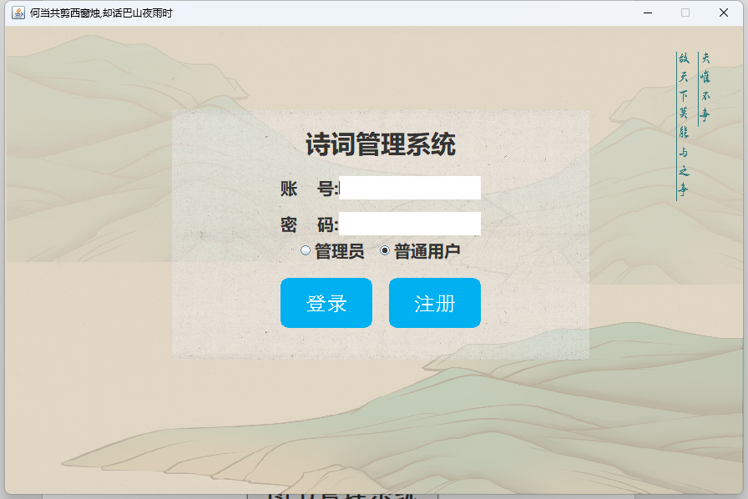

图2.1.1登录界面

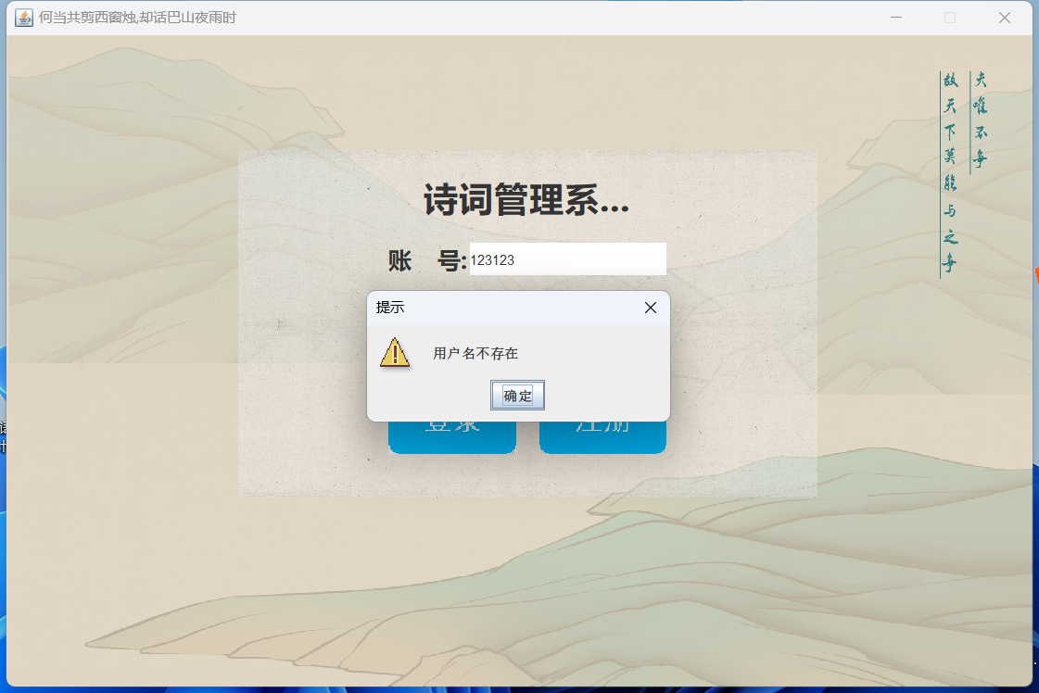

图2.1.2用户名不存在情况

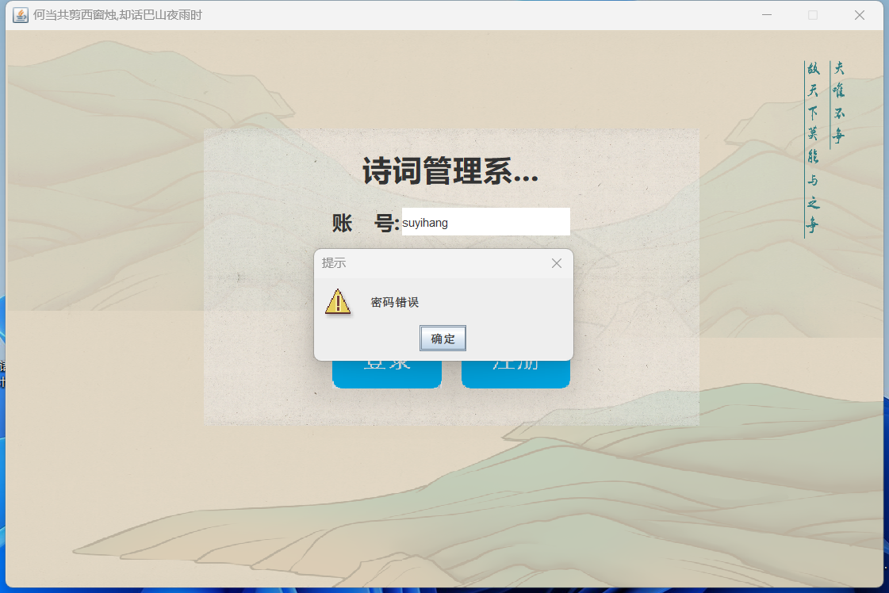

图2.1.3密码错误情况

（2）登录代码

**public class** LoginPanel **extends** JPanel {  
  
 **private static** JDesktopPane contentPanel = **new** JDesktopPane();  
 String dir = **"src\\images\\"**;  
 JPanel panel;  
 **public** LoginPanel() {  
 **this**.setBounds(0, 0, SystemConstants.FRAME_WIDTH, SystemConstants.FRAME_HEIGHT);  
 **this**.setLayout(**null**);  
 panel = **new** JPanel(){  
 @Override  
 **protected void** paintComponent(Graphics g){  
 Graphics2D g2 = (Graphics2D) g;  
 g2.drawImage(**new** ImageIcon(dir + **"001.png"**).getImage(), 0, 0,getWidth(), getHeight(), **null**);  
 }  
 };  
 panel.setBounds(200, 100, 500, 300);  
 **this**.add(panel);  
  
 *// 创建垂直表单* Box box = Box.createVerticalBox();  
 panel.add(box);  
 box.add(Box.createVerticalStrut(15));  
  
 Box box0 = Box.createHorizontalBox();  
 JLabel title = **new** JLabel(**"诗词管理系统"**);  
 title.setFont( **new** Font(**"微软雅黑"**, Font.BOLD, 30));  
 box0.add(title);  
 box.add(box0);  
 box.add(Box.createVerticalStrut(20));  
 box0.addMouseListener(**new** MouseAdapter() {  
 @Override  
 **public void** mouseClicked(MouseEvent e) {  
 box0.setBackground(Color.LIGHT_GRAY);  
 box0.repaint();  
 }  
 });  
  
 *// 设置字体与文本框格式* Font font = **new** Font(**"微软雅黑"**, Font.BOLD, 20);  
 Border border = BorderFactory.createCompoundBorder();  
 *// 账号输入* Box box1 = Box.createHorizontalBox();  
 JLabel nameLabel = **new** JLabel(**"账 号:"**);  
 nameLabel.setFont(font);  
 JTextField nameField = **new** JTextField(15);  
 nameField.setBorder(border);  
 box1.add(nameLabel);  
 box1.add(nameField);  
 box.add(box1);  
 box.add(Box.createVerticalStrut(15));  
 *// 密码输入* Box box2 = Box.createHorizontalBox();  
 JLabel passwordLabel = **new** JLabel(**"密 码:"**);  
 passwordLabel.setFont(font);  
 JPasswordField passwordField = **new** JPasswordField(15);  
 passwordField.setBorder(border);  
 box2.add(passwordLabel);  
 box2.add(passwordField);  
 box.add(box2);  
 *// 权限按钮* JRadioButton adminRadio = **new** JRadioButton(**"管理员"**);  
 JRadioButton commonRadio = **new** JRadioButton(**"普通用户"**, **true**);  
 adminRadio.setFont(font);  
 adminRadio.setOpaque(**false**);  
 adminRadio.setFocusPainted(**false**);  
  
 commonRadio.setFont(font);  
 commonRadio.setOpaque(**false**);  
 commonRadio.setFocusPainted(**false**);  
  
 ButtonGroup group = **new** ButtonGroup();*// 创建一个按钮组* group.add(adminRadio);  
 group.add(commonRadio);  
 Box box3 = Box.createHorizontalBox();  
 box3.add(adminRadio);  
 box3.add(Box.createHorizontalStrut(10));  
 box3.add(commonRadio);  
  
 box.add(box3);  
 box.add(Box.createVerticalStrut(15));  
  
 JButton loginBtn = **new** JButton();  
 Image login = **new** ImageIcon(dir + **"login_btn.png"**).getImage().getScaledInstance(110, 60, Image.SCALE_DEFAULT);  
 loginBtn.setIcon(**new** ImageIcon(login));  
 loginBtn.setBorderPainted(**false**);  
 loginBtn.setOpaque(**false**);  
 loginBtn.setContentAreaFilled(**false**);  
 loginBtn.setBorder(**null**);  
  
 loginBtn.addMouseListener(**new** MouseAdapter() {  
 @Override  
 **public void** mouseClicked(MouseEvent e) {  
 loginSkip(nameField.getText(), **new** String(passwordField.getPassword()), commonRadio.isSelected());  
 }  
 });  
 JButton regBtn = **new** JButton();  
 Image reg = **new** ImageIcon(dir + **"reg_btn.png"**).getImage().getScaledInstance(110, 60, Image.SCALE_DEFAULT);  
 regBtn.setIcon(**new** ImageIcon(reg));  
 regBtn.setBorderPainted(**false**);  
 regBtn.setOpaque(**false**);  
 regBtn.setContentAreaFilled(**false**);  
 regBtn.setBorder(**null**);  
  
 regBtn.addMouseListener(**new** MouseAdapter() {  
 @Override  
 **public void** mouseClicked(MouseEvent e) {  
 returnRegister();  
 }  
 });  
 Box box4 = Box.createHorizontalBox();  
 box4.add(loginBtn);  
 box4.add(Box.createHorizontalStrut(20));  
 box4.add(regBtn);  
 box.add(box4);  
  
 }  
 **private void** loginSkip(String name, String password, **boolean** isUser) {  
 **if** (isUser) {  
 judgeUser(name, password, **true**);  
 }**else** {  
 judgeUser(name, password, **false**);  
 }  
 }  
  
 **private void** judgeUser(String name, String password, **boolean** isUser){  
 **if** (name == **null**) {  
 **return**;  
 }  
 **if** (DataSelece.getPassword(name, isUser) == **null**) {  
 *// 弹窗,账号不存在* JOptionPane.showMessageDialog(**this**, **"用户名不存在"**, **"提示"**, JOptionPane.WARNING_MESSAGE);  
  
 } **else if** (!DataSelece.getPassword(name, isUser).equals(password)) {  
 *// 弹窗密码错误* JOptionPane.showMessageDialog(**this**, **"密码错误"**, **"提示"**, JOptionPane.WARNING_MESSAGE);  
 } **else** {  
 **try** {  
 **if** (isUser) {  
 **new** UserFrame().setVisible(**true**);  
 } **else** {  
 **new** AdminFrame().setVisible(**true**);  
 }  
 *// 获取 panel 所在的 JFrame 对象* JFrame parentFrame = (JFrame) SwingUtilities.getWindowAncestor(panel);  
 *// 现在可以使用 parentFrame 对象进行操作，比如关闭窗口* parentFrame.dispose(); *// 关闭 JFrame* } **catch** (PropertyVetoException ex) {  
 ex.printStackTrace();  
 }  
 }  
 }  
  
 **private void** returnRegister() {  
 *// 获取顶层容器（JFrame）* JFrame topFrame = (JFrame) SwingUtilities.getWindowAncestor(**this**);  
  
 *// 切换内容面板为LoginPanel* topFrame.setContentPane(**new** RegisterPanel());  
  
 *// 重新布局顶层容器* topFrame.revalidate();  
 topFrame.repaint();  
 }  
  
 @Override  
 **protected void** paintComponent(Graphics g){  
 Graphics2D g2 = (Graphics2D) g;  
 g2.drawImage(**new** ImageIcon(dir + **"bg1.png"**).getImage(), 0, 0,getWidth(), getHeight(), **null**);  
 }  
}

### 2.3.2 注册功能实现

（1） 用户注册界面

若用户名与已有用户名重复，则弹出提示“用户名重复”、若两次输入密码不一致，则弹出提示，两次密码不一致。如没有问题，注册成功则弹出“注册成功”提示。

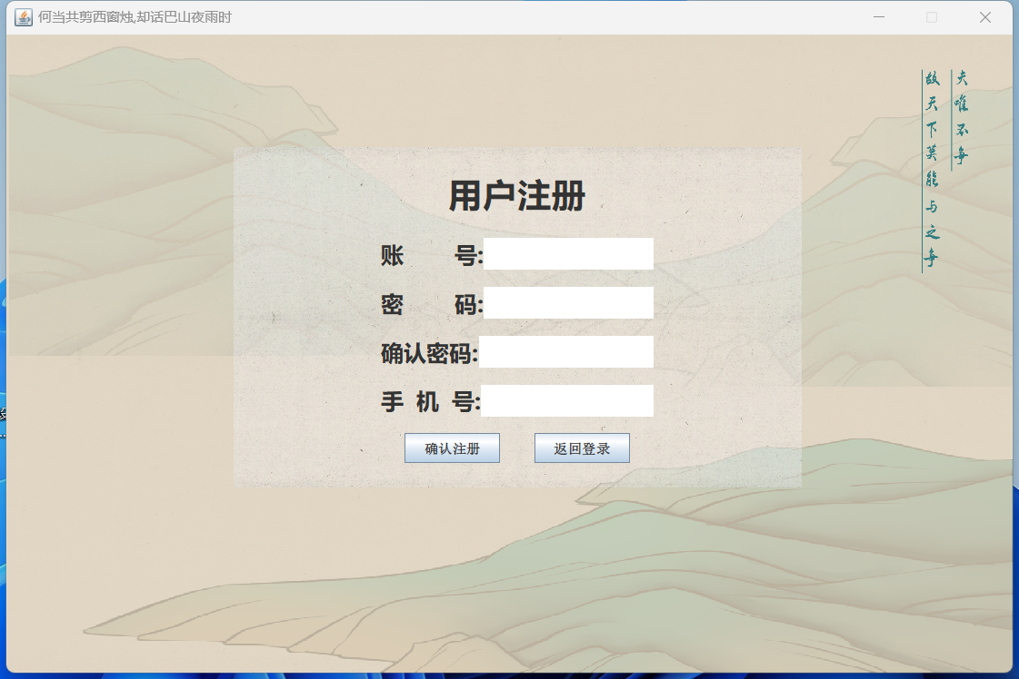

图2.2.1 用户注册界面

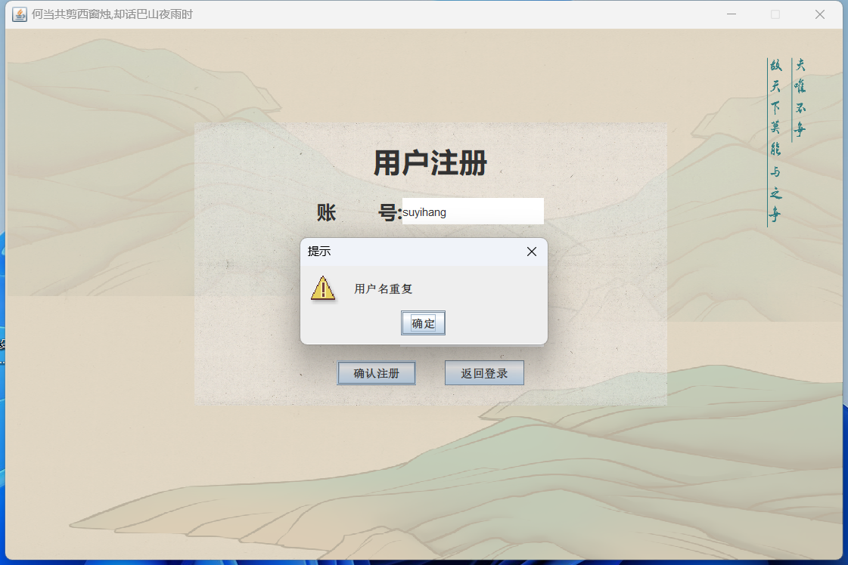

图2.2.2用户名重复提示

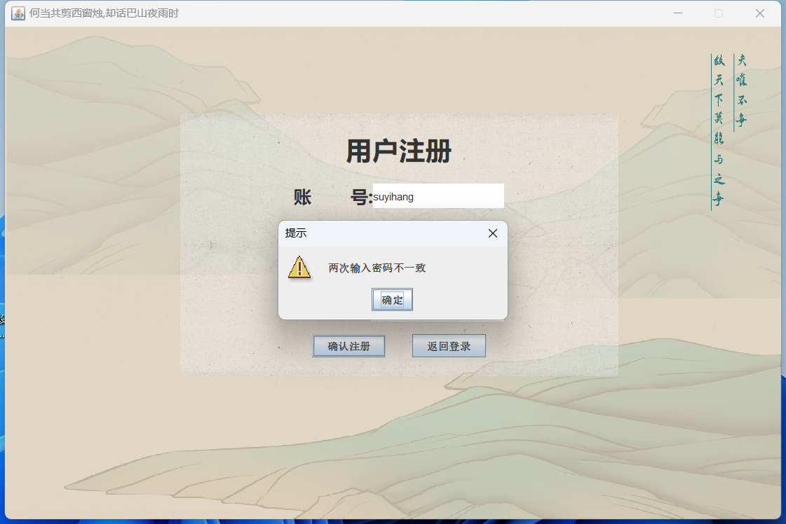

图2.2.3两次输入密码不一致提示

,（2）注册代码

**public class** RegisterPanel **extends** JPanel {  
  
 **private static** JDesktopPane contentPanel = **new** JDesktopPane();  
  
 String dir = **"src\\images\\"**;  
  
 JPanel panel;  
  
 **public** RegisterPanel() {  
 **this**.setBounds(0, 0, SystemConstants.FRAME_WIDTH, SystemConstants.FRAME_HEIGHT);  
 **this**.setLayout(**null**);  
  
 panel = **new** JPanel(){  
 @Override  
 **protected void** paintComponent(Graphics g){  
 Graphics2D g2 = (Graphics2D) g;  
 g2.drawImage(**new** ImageIcon(dir + **"001.png"**).getImage(), 0, 0,getWidth(), getHeight(), **null**);  
 }  
 };  
 panel.setBounds(200, 100, 500, 300);  
 **this**.add(panel);  
  
 *// 创建垂直表单* Box box = Box.createVerticalBox();  
 panel.add(box);  
 box.add(Box.createVerticalStrut(15));  
  
 Box box0 = Box.createHorizontalBox();  
 JLabel title = **new** JLabel(**"用户注册"**);  
 title.setFont( **new** Font(**"微软雅黑"**, Font.BOLD, 30));  
 box0.add(title);  
 box.add(box0);

box.add(Box.createVerticalStrut(20));

box0.addMouseListener(**new** MouseAdapter() {  
 @Override  
 **public void** mouseClicked(MouseEvent e) {  
 box0.setBackground(Color.LIGHT_GRAY);  
 box0.repaint();  
 }  
 });  
  
 *// 设置字体与文本框格式* Font font = **new** Font(**"微软雅黑"**, Font.BOLD, 20);  
 Border border = BorderFactory.createCompoundBorder();  
  
 *// 账号输入* Box box1 = Box.createHorizontalBox();  
 JLabel nameLabel = **new** JLabel(**"账 号:"**);  
 nameLabel.setFont(font);  
 JTextField nameField = **new** JTextField(15);  
 nameField.setBorder(border);  
 box1.add(nameLabel);  
 box1.add(nameField);  
 box.add(box1);  
  
 box.add(Box.createVerticalStrut(15));  
  
 *// 确认密码输入* Box box2 = Box.createHorizontalBox();  
 JLabel passwordLabel = **new** JLabel(**"密 码:"**);  
 passwordLabel.setFont(font);  
 JPasswordField passwordField = **new** JPasswordField(15);  
 passwordField.setBorder(border);  
 box2.add(passwordLabel);  
 box2.add(passwordField);  
 box.add(box2);

box.add(Box.createVerticalStrut(15));

Box box3 = Box.createHorizontalBox();  
 JLabel passwordLabel2 = **new** JLabel(**"确认密码:"**);  
 passwordLabel2.setFont(font);  
 JPasswordField passwordField2 = **new** JPasswordField(15);  
 passwordField2.setBorder(border);  
 box3.add(passwordLabel2);  
 box3.add(passwordField2);  
 box.add(box3);

box.add(Box.createVerticalStrut(15));

*// 手机号* Box box4 = Box.createHorizontalBox();  
 JLabel telLabel = **new** JLabel(**"手 机 号:"**);  
 telLabel.setFont(font);  
 JTextField telField = **new** JTextField(15);  
 telField.setBorder(border);  
 box4.add(telLabel);  
 box4.add(telField);  
 box.add(box4);

box.add(Box.createVerticalStrut(15));

Box box5 = Box.createHorizontalBox();  
 JButton sureReg = **new** JButton(**"确认注册"**);  
 JButton retuLog = **new** JButton(**"返回登录"**);  
 box5.add(sureReg);  
 box5.add(Box.createHorizontalStrut(30));  
 box5.add(retuLog);  
 box.add(box5);  
  
 sureReg.addMouseListener(**new** MouseAdapter() {  
 @Override  
 **public void** mouseClicked(MouseEvent e) {  
 Register(nameField.getText(), **new** String(passwordField.getPassword()),  
 **new** String(passwordField2.getPassword()) , telField.getText());  
 }  
 });  
 retuLog.addMouseListener(**new** MouseAdapter() {  
 @Override  
 **public void** mouseClicked(MouseEvent e) {  
 returnLogin();  
 }  
 });  
 }  
 @Override  
 **protected void** paintComponent(Graphics g){  
 Graphics2D g2 = (Graphics2D) g;  
 g2.drawImage(**new** ImageIcon(dir + **"bg1.png"**).getImage(), 0, 0,getWidth(), getHeight(), **null**);  
 }  
 **private void** Register(String account, String password, String password2, String telephone){  
 **if** (account.isEmpty() || password.isEmpty()) {  
 JOptionPane.showMessageDialog(**this**, **"账号或密码不能为空"**, **"提示"**, JOptionPane.WARNING_MESSAGE);  
 } **else if** (!password.equals(password2)) {  
 JOptionPane.showMessageDialog(**this**, **"两次输入密码不一致"**, **"提示"**, JOptionPane.WARNING_MESSAGE);  
 } **else if** (password.length() < 6){  
 JOptionPane.showMessageDialog(**this**, **"密码长度不得小于6个字符"**, **"提示"**, JOptionPane.WARNING_MESSAGE);  
 } **else** {  
 **if** (DataInsert.UserInsert(account, password, telephone)) {  
 JOptionPane.showMessageDialog(**this**, **"注册成功"**, **"提示"**, JOptionPane.WARNING_MESSAGE);  
 } **else**{  
 JOptionPane.showMessageDialog(**this**, **"用户名重复"**, **"提示"**, JOptionPane.WARNING_MESSAGE);  
 }  
 }  
 }  
 **private void** returnLogin() {  
 *// 获取顶层容器（JFrame）* JFrame topFrame = (JFrame) SwingUtilities.getWindowAncestor(**this**);  
  
 *// 切换内容面板为LoginPanel* topFrame.setContentPane(**new** LoginPanel());  
  
 *// 重新布局顶层容器* topFrame.revalidate();  
 topFrame.repaint();  
 }  
}

### 2.3.3 用户端-诗词集锦功能实现

（1）功能面板

单击某一项表格数据，诗词的全部信息显示在右侧表格中，若诗词过长，则添加滑动滚轮。右方下侧代表收藏功能，若点亮五角星，则代表该诗词已被收藏。单击可切换收藏状态。

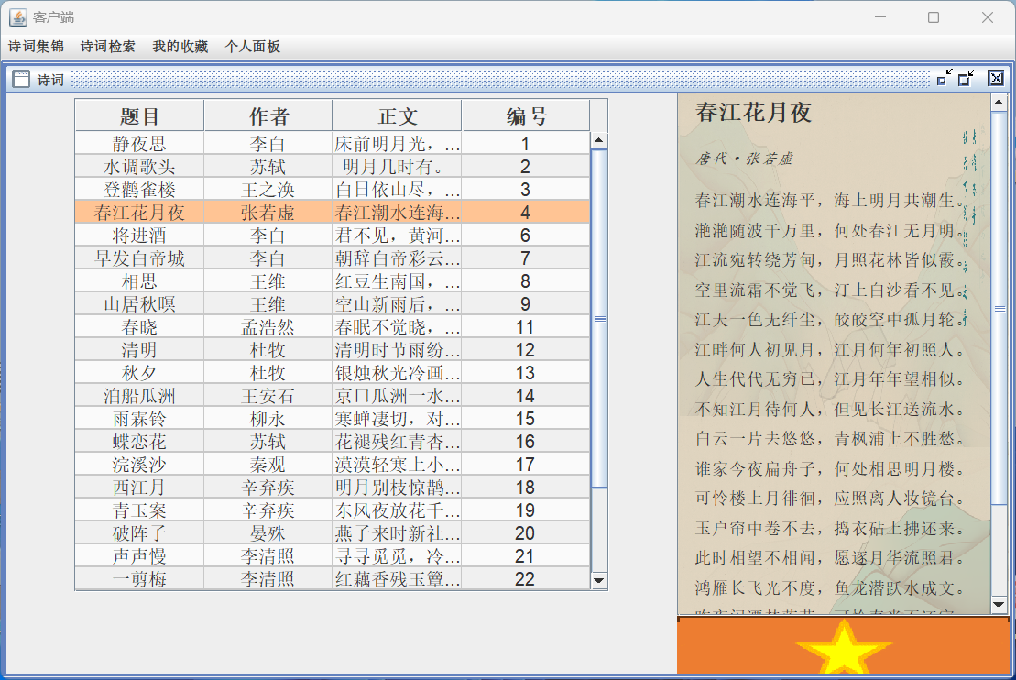

图2.3.1 长诗词展示（已收藏）

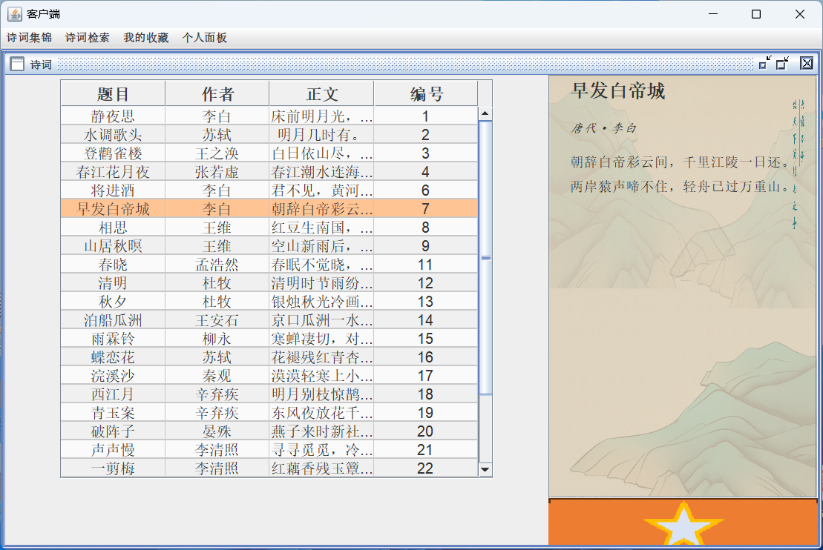

图2.3.2 短诗词展示（未收藏）

（2）代码实现：

**public class** PoetrysHome **extends** JInternalFrame {  
  
 **public** PoetrysHome() **throws** SQLException {  
 **super**(**"诗词"**, **true**, **true**, **true**, **true**);  
 initLeftPanel();  
 initRightPanel();  
  
 *// 默认最大化* **try** {  
 setMaximum(**true**);  
 } **catch** (PropertyVetoException e) {  
 e.printStackTrace();  
 }  
 }  
  
 *// 表格中的数据* Object[][] data = {};  
 DefaultTableModel tableModel;  
  
 JTable table = **new** JTable();  
  
 **public void** initLeftPanel() **throws** SQLException {  
 JPanel LeftPanel = **new** JPanel();  
 *// 单选* table.setSelectionMode(ListSelectionModel.SINGLE_INTERVAL_SELECTION);  
  
 Object[] columnNames = {**"题目"**, **"作者"**, **"正文"**, **"编号"**};  
  
 tableModel = **new** DefaultTableModel(data, columnNames) {  
 @Override  
 **public boolean** isCellEditable(**int** row, **int** column) {  
 *// 所有单元格都不可编辑* **return false**;  
 }  
 };  
  
 table = **new** JTable(tableModel);  
  
 ArrayList<Poetry> poetries = DataSelece.getAllPoetrys();  
  
 **for** (Poetry poetry:poetries) {  
 String title = poetry.getTitle();  
 String author = poetry.getAuthor();  
 String text = poetry.getText()[0];  
 **int** id = poetry.getPoetry_id();  
 Object[] rowData = {title, author, text, id};  
 tableModel.addRow(rowData);  
*// System.out.println(title); // debug* }  
 JScrollPane jScrollPane = **new** JScrollPane(table);  
  
 beautiful();  
  
 table.addMouseListener(**new** MouseAdapter() {  
 @Override  
 **public void** mouseClicked(MouseEvent e) {  
 **try** {  
 refreshPanel();  
 } **catch** (SQLException ex) {  
 ex.printStackTrace();  
 }  
 }  
 });  
  
 LeftPanel.add(jScrollPane, BorderLayout.CENTER);  
  
 **this**.add(LeftPanel, BorderLayout.CENTER);  
  
 }  
 JPanel boxPanel = **new** JPanel(){  
 @Override  
 **protected void** paintComponent(Graphics g){  
 Graphics2D g2 = (Graphics2D) g;  
 g2.drawImage(**new** ImageIcon(SystemConstants.dir + **"bg1.png"**).getImage(), 0, 0,getWidth(), getHeight(), **null**);  
 }  
 };  
  
 JButton collectButtom;  
 **public void** initRightPanel() {  
 JPanel RightPanel = **new** JPanel();  
 RightPanel.setLayout(**new** BorderLayout());  
  
 JPanel PoetryPanel = **new** JPanel(){  
 @Override  
 **protected void** paintComponent(Graphics g){  
 Graphics2D g2 = (Graphics2D) g;  
 g2.drawImage(**new** ImageIcon(SystemConstants.dir + **"001.png"**).getImage(), 0, 0,getWidth(), getHeight(), **null**);  
 }  
 };  
 PoetryPanel.setPreferredSize(**new** Dimension(250, 450)); *// 设置固定宽度，高度随内容增加* PoetryPanel.setBackground(Color.GREEN); *// 可以为了示例性而设置背景色，便于观察* JScrollPane jScrollPane = **new** JScrollPane(boxPanel){  
 @Override  
 **protected void** paintComponent(Graphics g){  
 Graphics2D g2 = (Graphics2D) g;  
 g2.drawImage(**new** ImageIcon(SystemConstants.dir + **"bg1.png"**).getImage(), 0, 0,getWidth(), getHeight(), **null**);  
 }  
 };  
 jScrollPane.setPreferredSize(**new** Dimension(280, 460));  
  
 RightPanel.add(jScrollPane, BorderLayout.CENTER);  
  
 JPanel collectPanel = **new** JPanel(){  
 @Override  
 **protected void** paintComponent(Graphics g){  
 Graphics2D g2 = (Graphics2D) g;  
 g2.drawImage(**new** ImageIcon(SystemConstants.dir + **"collect.png"**).getImage(), 0, 0,getWidth(), getHeight(), **null**);  
 }  
 };  
  
 *// 收藏按钮* collectButtom = **new** JButton();  
  
 collectButtom.setBorderPainted(**false**);  
 collectButtom.setOpaque(**false**);  
 collectButtom.setContentAreaFilled(**false**);  
 collectButtom.setBorder(**null**);  
 collectButtom.setPreferredSize(**new** Dimension(290, 50));  
 collectPanel.add(collectButtom, BorderLayout.SOUTH);  
 collectButtom.addMouseListener(**new** MouseAdapter() {  
 @Override  
 **public void** mouseClicked(MouseEvent e) {  
 **try** {  
 collectPoetry();  
 } **catch** (SQLException ex) {  
 ex.printStackTrace();  
 }  
 }  
 });  
  
 collectPanel.setPreferredSize(**new** Dimension(290, 50));  
  
 RightPanel.add(collectPanel, BorderLayout.SOUTH);  
  
 **this**.add(RightPanel, BorderLayout.EAST);  
 }  
  
 **private boolean** isCollect(**int** poetryID) **throws** SQLException {  
 **return** DataSelece.isExitCollect(poetryID);  
 }  
  
 **private void** collectPoetry() **throws** SQLException {  
 **int** poetryID = getSelectPoetrID();  
 **if** (isCollect(poetryID)) {  
 DataDelete.StarDelete(poetryID);  
 } **else** {  
 DataInsert.StarInsert(poetryID);  
 }  
  
 refreshStar(isCollect(poetryID));  
 }  
  
 **private void** refreshStar(**boolean** isStar) {  
 **if** (isStar) {  
 Image collect = **new** ImageIcon(SystemConstants.dir + **"collected.png"**).getImage().getScaledInstance(300, 70, Image.SCALE_DEFAULT);  
 collectButtom.setIcon(**new** ImageIcon(collect));  
 }  
 **else** {  
 Image collect = **new** ImageIcon(SystemConstants.dir + **"collect.png"**).getImage().getScaledInstance(300, 70, Image.SCALE_DEFAULT);  
 collectButtom.setIcon(**new** ImageIcon(collect));  
 }  
 }  
  
 **private int** getSelectPoetrID() {  
 **int** rowNum = table.getSelectedRow();  
 **if** (rowNum < 0) **return** -1;  
  
 *// 获取表格模型* DefaultTableModel model = (DefaultTableModel) table.getModel();  
 *// 获取id* TableColumnModel columnModel = table.getColumnModel();  
 **int** columnIndexInView = columnModel.getColumnIndex(**"编号"**);  
 **int** columnIndexInModel = table.convertColumnIndexToModel(columnIndexInView);  
  
 **return** (**int**) model.getValueAt(rowNum, columnIndexInModel);  
 }  
  
 **private void** refreshPanel() **throws** SQLException {  
  
 **int** id = getSelectPoetrID();  
  
 **if** (id < 0) **return**;  
  
 Poetry poetry = DataSelece.IDtoPoetry(id);  
  
 *// 更新右侧面板的内容* boxPanel.removeAll(); *// 清空原有内容  
  
 // 定义字体* Font titleFont = **new** Font(**"宋体"**, Font.BOLD, 20); *// Example: Arial, bold, size 18* Font authorFont = **new** Font(**"楷体"**, Font.ITALIC, 14); *// Example: Times New Roman, italic, size 14* Font contentFont = **new** Font(**"宋体"**, Font.PLAIN, 15); *// Example: Calibri, plain, size 12* Box box = Box.createVerticalBox();  
 **assert** poetry != **null**;  
 *// 添加标题* JLabel jLabelTitle = **new** JLabel(poetry.getTitle());  
 jLabelTitle.setFont(titleFont);  
 box.add(jLabelTitle);  
 box.add(Box.createVerticalStrut(20));  
 *// 添加作者* JLabel jLabelAuthor = **new** JLabel(poetry.getDynasty() + **"·"** + poetry.getAuthor());  
 jLabelAuthor.setFont(authorFont);  
 box.add(jLabelAuthor);  
 box.add(Box.createVerticalStrut(20));  
 *// 添加正文* **for** (String content:poetry.getText()){  
 JLabel jLabelContent = **new** JLabel(content);  
 jLabelContent.setFont(contentFont);  
 box.add(jLabelContent);  
 box.add(Box.createVerticalStrut(8));  
 }  
  
 boxPanel.add(box);  
  
 *// 更新收藏按钮* refreshStar(isCollect(id));  
 *// 重新绘制面板* boxPanel.revalidate();  
 boxPanel.repaint();  
  
 }  
 **private void** beautiful() {  
 JTable jTable = table;  
 *// 设置表格的字体和行高* jTable.setFont(**new** Font(**"SansSerif"**, Font.PLAIN, 16));  
 jTable.setRowHeight(20);  
 *// 自定义表头的样式* JTableHeader tableHeader = jTable.getTableHeader();  
 tableHeader.setFont(**new** Font(**"SansSerif"**, Font.BOLD, 18));  
 tableHeader.setBackground(**new** Color(240, 240, 240)); *// 浅灰色* tableHeader.setForeground(**new** Color(60, 60, 60)); *// 深灰色  
 // 设置表格的网格线颜色* jTable.setGridColor(**new** Color(200, 200, 200)); *// 灰色  
 // 自定义单元格渲染器* DefaultTableCellRenderer centerRenderer = **new** DefaultTableCellRenderer() {  
 @Override  
 **public** Component getTableCellRendererComponent(JTable table, Object value, **boolean** isSelected, **boolean** hasFocus, **int** row, **int** column) {  
 Component c = **super**.getTableCellRendererComponent(table, value, isSelected, hasFocus, row, column);  
 **if** (!isSelected) {  
 c.setBackground(row % 2 == 0 ? **new** Color(250, 250, 250) : **new** Color(240, 240, 240)); *// 交替行颜色：白色和浅灰色* }  
 **return** c;  
 }  
 };  
 centerRenderer.setHorizontalAlignment(SwingConstants.CENTER);  
 **for** (**int** i = 0; i < jTable.getColumnCount(); i++) {  
 jTable.getColumnModel().getColumn(i).setCellRenderer(centerRenderer);  
 }  
 *// 设置选中颜色* jTable.setSelectionBackground(**new** Color(255, 196, 148)); *// 浅蓝色* jTable.setSelectionForeground(**new** Color(60, 60, 60)); *// 深灰色* }  
 **private void** beautiful2() {  
 JTable jTable = table;  
 *// 设置表格的字体和行高* jTable.setFont(**new** Font(**"楷体"**, Font.PLAIN, 16));  
 jTable.setRowHeight(25);  
 *// 自定义表头的样式* JTableHeader tableHeader = jTable.getTableHeader();  
 tableHeader.setFont(**new** Font(**"黑体"**, Font.BOLD, 18));  
 tableHeader.setBackground(**new** Color(139, 69, 19)); *// 棕色* tableHeader.setForeground(Color.WHITE);  
 *// 设置表格的网格线颜色* jTable.setGridColor(**new** Color(160, 82, 45)); *// 深棕色  
 // 自定义单元格渲染器* DefaultTableCellRenderer centerRenderer = **new** DefaultTableCellRenderer() {  
 @Override  
 **public** Component getTableCellRendererComponent(JTable table, Object value, **boolean** isSelected, **boolean** hasFocus, **int** row, **int** column) {  
 Component c = **super**.getTableCellRendererComponent(table, value, isSelected, hasFocus, row, column);  
 **if** (!isSelected) {  
 c.setBackground(row % 2 == 0 ? **new** Color(245, 222, 179) : **new** Color(255, 235, 205)); *// 交替行颜色：小麦色和杏仁白* }  
 **return** c;  
 }  
 };  
 centerRenderer.setHorizontalAlignment(SwingConstants.CENTER);  
 **for** (**int** i = 0; i < jTable.getColumnCount(); i++) {  
 jTable.getColumnModel().getColumn(i).setCellRenderer(centerRenderer);  
 }  
 *// 设置选中颜色* jTable.setSelectionBackground(**new** Color(210, 180, 140)); *// 浅棕色* jTable.setSelectionForeground(Color.BLACK);  
 }  
}

### 2.3.4 用户端-诗词检索功能的实现

（1）界面截图

可在下方输入栏进行多条兼模糊查找，同时，可以添加诗词到收藏面板，单击表格中的诗词，可完整显示于下方面板。添加收藏和取消收藏通过鼠标选择实现

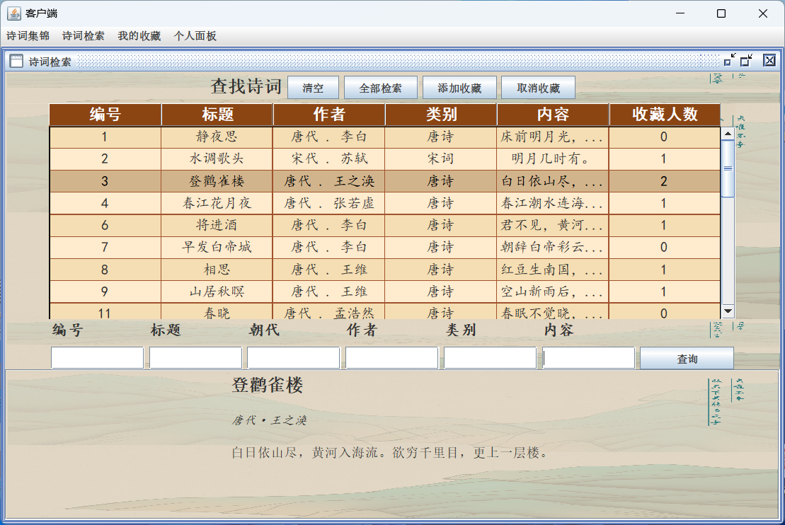

图2.4.1 检索全部诗词

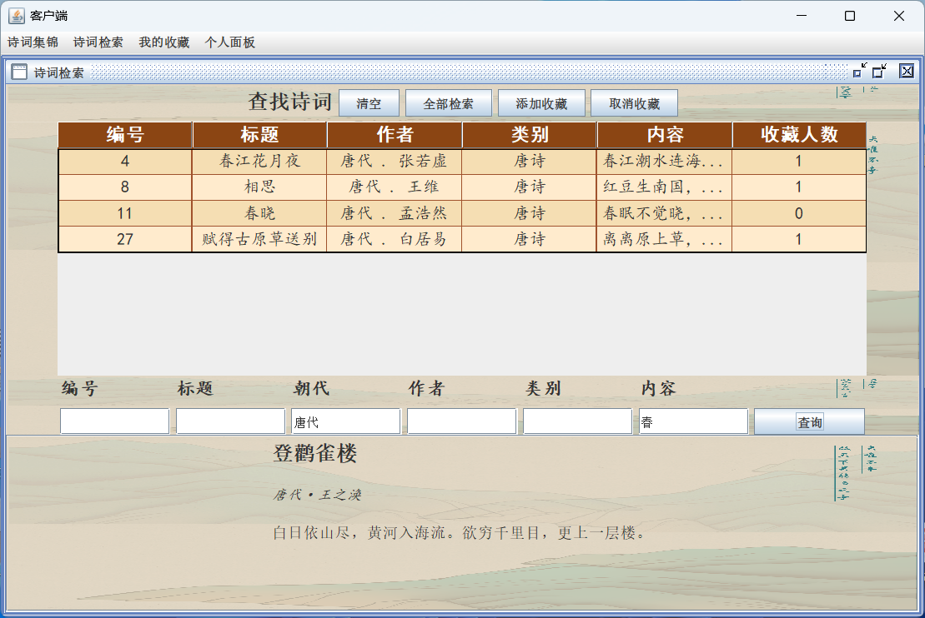

图2.4.2 查找所有含有“春”字的唐诗

（2） 代码实现

界面省略，只提供实现逻辑的函数

*// 查找全部数据并更新到表格* **private void** refreshTable() {  
 ArrayList<Poetry> poetries = DataSelece.getAllPoetrys();  
 tableModel.setRowCount(0);  
 **for** (Poetry p:poetries) {  
 String dynast = p.getDynasty() +**" . "** + p.getAuthor();  
 **int** stars = DataSelece.getStarNumber(p.getPoetry_id());  
 Object[] rowData = {p.getPoetry_id(), p.getTitle(), dynast, p.getType(), p.getText()[0], stars};  
 tableModel.addRow(rowData);  
 }  
 }  
  
 *// 获取选中表格中诗词的ID* **private int** getSelectPoetrID() {  
 **int** rowNum = jTable.getSelectedRow();  
 **if** (rowNum < 0) **return** -1;  
  
 *// 获取表格模型* DefaultTableModel model = (DefaultTableModel) jTable.getModel();  
 *// 获取id* TableColumnModel columnModel = jTable.getColumnModel();  
 **int** columnIndexInView = columnModel.getColumnIndex(**"编号"**);  
 **int** columnIndexInModel = jTable.convertColumnIndexToModel(columnIndexInView);  
  
 **return** (**int**) model.getValueAt(rowNum, columnIndexInModel);  
 }  
 **private int** getSelectPoetrID(**int** x) {  
 **int** rowNum = x;  
 **if** (rowNum < 0) **return** -1;  
  
 *// 获取表格模型* DefaultTableModel model = (DefaultTableModel) jTable.getModel();  
 *// 获取id* TableColumnModel columnModel = jTable.getColumnModel();  
 **int** columnIndexInView = columnModel.getColumnIndex(**"编号"**);  
 **int** columnIndexInModel = jTable.convertColumnIndexToModel(columnIndexInView);  
  
 **return** (**int**) model.getValueAt(rowNum, columnIndexInModel);  
 }  
  
 *// 将表格中选中的诗词更新在下方面板* Box box;  
 **private void** refreshText() {  
 **int** id = getSelectPoetrID();  
 **if** (id < 0) **return**;  
  
 Poetry poetry = DataSelece.IDtoPoetry(id);  
  
 *// 清空所有内容;* boxPanel.removeAll();  
  
 *// 定义字体* Font titleFont = **new** Font(**"宋体"**, Font.BOLD, 20); *// Example: Arial, bold, size 18* Font authorFont = **new** Font(**"楷体"**, Font.ITALIC, 14); *// Example: Times New Roman, italic, size 14* Font contentFont = **new** Font(**"宋体"**, Font.PLAIN, 15); *// Example: Calibri, plain, size 12* box = Box.createVerticalBox();  
 **assert** poetry != **null**;  
 *// 添加标题* JLabel jLabelTitle = **new** JLabel(poetry.getTitle());  
 jLabelTitle.setFont(titleFont);  
 box.add(jLabelTitle);  
 box.add(Box.createVerticalStrut(20));  
 *// 添加作者* JLabel jLabelAuthor = **new** JLabel(poetry.getDynasty() + **"·"** + poetry.getAuthor());  
 jLabelAuthor.setFont(authorFont);  
 box.add(jLabelAuthor);  
 box.add(Box.createVerticalStrut(20));  
 *// 添加正文* String[] text = poetry.getText();  
 **for** (**int** i = 0 ; i < text.length; i = i + 2){  
 String strtext = text[i];  
 **if** (i + 1 < text.length) strtext += text[i + 1];  
 JLabel jLabelContent = **new** JLabel(strtext);  
 jLabelContent.setFont(contentFont);  
 box.add(jLabelContent);  
 box.add(Box.createVerticalStrut(8));  
 }  
 boxPanel.add(box);  
 *// 重新绘制面板* boxPanel.revalidate();  
 boxPanel.repaint();  
 jScrollPane.revalidate();  
 jScrollPane.repaint();  
 }  
  
 *// 多条件模糊查找* **private void** findPoetry(String newId, String newTitle, String newDynast, String newAuthor,  
 String newType, String newText){  
 ArrayList<Poetry> poetries = DataSelece.FindByCriteria(newId, newTitle, newDynast, newAuthor, newType, newText);  
 tableModel.setRowCount(0);  
 **for** (Poetry p:poetries) {  
 String dynast = p.getDynasty() +**" . "** + p.getAuthor();  
 **int** stars = DataSelece.getStarNumber(p.getPoetry_id());  
 Object[] rowData = {p.getPoetry_id(), p.getTitle(), dynast, p.getType(), p.getText()[0], stars};  
 tableModel.addRow(rowData);  
 }  
 }  
  
 *// 取消收藏* **private void** Unfavorite(){  
 **int**[] selectRows = jTable.getSelectedRows();  
  
 **if** (selectRows.length == 0) **return**;  
 **for**(**int** x:selectRows){  
 **int** id = getSelectPoetrID(x); *// 获取选中列的id* DataDelete.StarDelete(id); *// 取消收藏* }  
 refreshTable();  
 }  
  
 **private void** AddStar(){  
 **int**[] selectRows = jTable.getSelectedRows();  
  
 **if** (selectRows.length == 0) **return**;  
 **for**(**int** x:selectRows){  
 **int** id = getSelectPoetrID(x); *// 获取选中列的id* DataInsert.StarInsert(id); *// 取消收藏* }  
 refreshTable();  
 }  
*// 美化面板* **private void** beautiful() {  
  
 *// 设置表格的字体和行高* jTable.setFont(**new** Font(**"SansSerif"**, Font.PLAIN, 16));  
 jTable.setRowHeight(20);  
  
 *// 自定义表头的样式* JTableHeader tableHeader = jTable.getTableHeader();  
 tableHeader.setFont(**new** Font(**"SansSerif"**, Font.BOLD, 18));  
 tableHeader.setBackground(**new** Color(240, 240, 240)); *// 浅灰色* tableHeader.setForeground(**new** Color(60, 60, 60)); *// 深灰色  
  
 // 设置表格的网格线颜色* jTable.setGridColor(**new** Color(200, 200, 200)); *// 灰色  
  
 // 自定义单元格渲染器* DefaultTableCellRenderer centerRenderer = **new** DefaultTableCellRenderer() {  
 @Override  
 **public** Component getTableCellRendererComponent(JTable table, Object value, **boolean** isSelected, **boolean** hasFocus, **int** row, **int** column) {  
 Component c = **super**.getTableCellRendererComponent(table, value, isSelected, hasFocus, row, column);  
 **if** (!isSelected) {  
 c.setBackground(row % 2 == 0 ? **new** Color(250, 250, 250) : **new** Color(240, 240, 240)); *// 交替行颜色：白色和浅灰色* }  
 **return** c;  
 }  
 };  
 centerRenderer.setHorizontalAlignment(SwingConstants.CENTER);  
  
 **for** (**int** i = 0; i < jTable.getColumnCount(); i++) {  
 jTable.getColumnModel().getColumn(i).setCellRenderer(centerRenderer);  
 }  
  
 *// 设置选中颜色* jTable.setSelectionBackground(**new** Color(180, 220, 240)); *// 浅蓝色* jTable.setSelectionForeground(**new** Color(60, 60, 60)); *// 深灰色* }

### 2.3.5 用户端-我的收藏功能实现

（1）界面截图

通过鼠标选择可以将诗词展示在下方面板，也可以取消收藏。同时可以进行多条件模糊查找，以及按编号精确查找。同时，增添将收藏的诗词经筛选后批量导出的功能。若，导出成功，则提示“已成功导出X条数据”，X为导出诗词的个数。

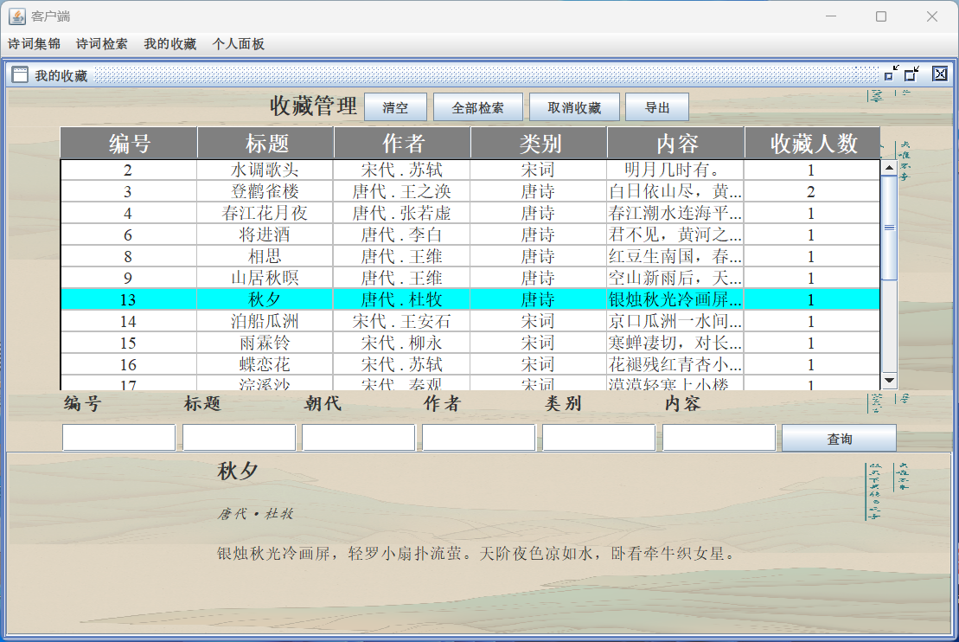

图2.5.1 主要界面

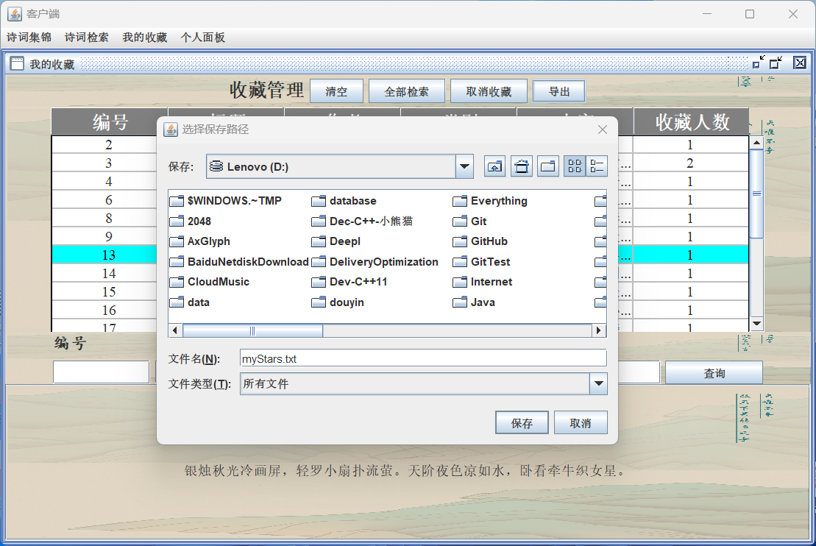

图2.5.2 导出收藏数据

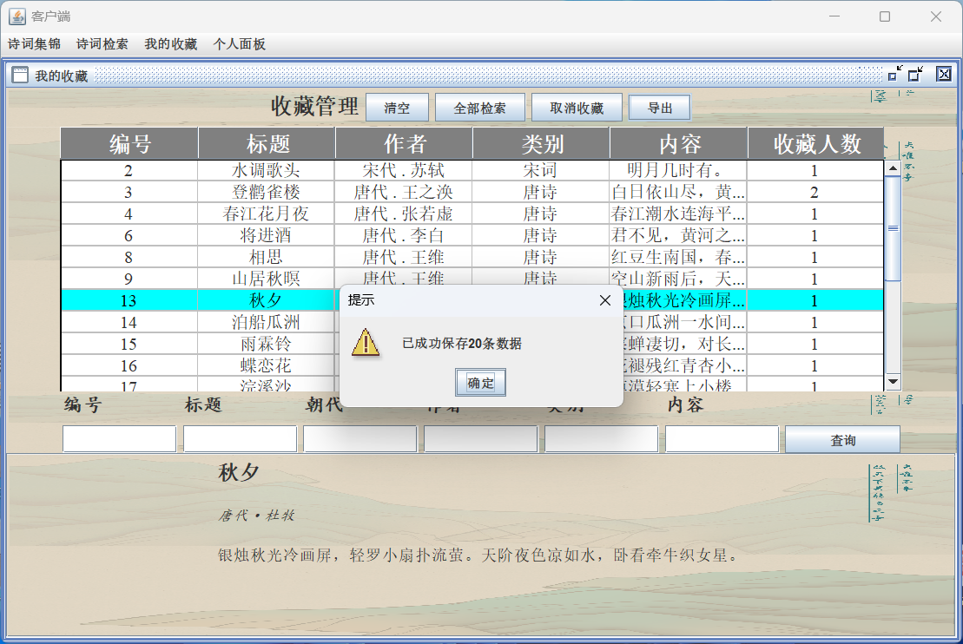

图2.5.3 导出成功提示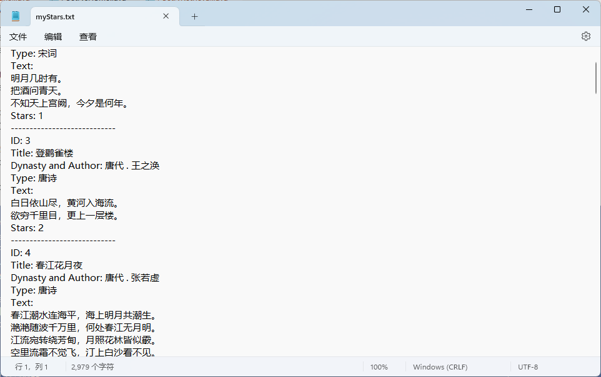

图2.5.4 导出后的格式

（2）功能代码

只展示导出功能的代码，其他代码省略。

**private void** ExportToFile(String newId, String newTitle, String newDynast, String newAuthor,  
 String newType, String newText) {  
 ArrayList<Poetry> poetries = DataSelece.*FindByStarCriteria*(newId, newTitle, newDynast, newAuthor, newType, newText);  
 **if** (poetries.isEmpty()) {  
 JOptionPane.*showMessageDialog*(**this**, **"未选择任何数据!"**, **"提示"**, JOptionPane.***WARNING_MESSAGE***);  
 **return**;  
 }  
 *// 创建文件选择器* JFileChooser fileChooser = **new** JFileChooser();  
 fileChooser.setDialogTitle(**"选择保存路径"**);  
 *// 显示保存对话框* **int** userSelection = fileChooser.showSaveDialog(**null**);  
 *// 执行导出操作* **if** (userSelection == JFileChooser.***APPROVE_OPTION***) {  
 *// 获取选择的文件* java.io.File fileToSave = fileChooser.getSelectedFile();  
 String filePath = fileToSave.getAbsolutePath();  
 *// 如果文件没有扩展名，添加".txt"* **if** (!filePath.endsWith(**".txt"**)) {  
 filePath += **".txt"**;  
 }  
  
 **try** (BufferedWriter writer = **new** BufferedWriter(**new** FileWriter(filePath))) {  
 **for** (Poetry p : poetries) {  
 String dynast = p.getDynasty() + **" . "** + p.getAuthor();  
 **int** stars = DataSelece.*getStarNumber*(p.getPoetry_id());  
 String text = String.*join*(**"\n"**, p.getText()); *// assuming p.getText() returns a String array* writer.write(**"ID: "** + p.getPoetry_id());  
 writer.newLine();  
 writer.write(**"Title: "** + p.getTitle());  
 writer.newLine();  
 writer.write(**"Dynasty and Author: "** + dynast);  
 writer.newLine();  
 writer.write(**"Type: "** + p.getType());  
 writer.newLine();  
 writer.write(**"Text: \n"** + text);  
 writer.newLine();  
 writer.write(**"Stars: "** + stars);  
 writer.newLine();  
 writer.write(**"----------------------------"**);  
 writer.newLine();  
 }  
 JOptionPane.*showMessageDialog*(**this**, **"已成功保存"** + poetries.size() + **"条数据"**, **"提示"**, JOptionPane.***WARNING_MESSAGE***);  
  
 } **catch** (IOException e) {  
 e.printStackTrace();  
 }  
 }  
}

### 2.3.6 用户端-个人面板的实现

展示了当前登录用户的全部数据，同时提供修改密码和退出登录的功能

1. 界面截图：

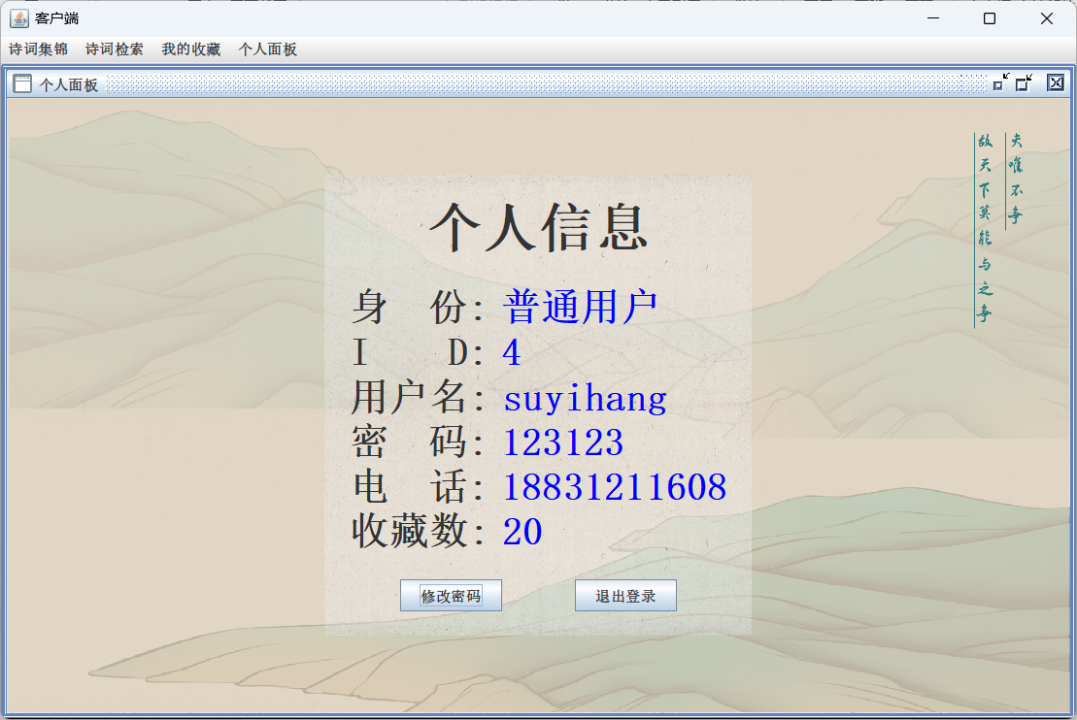

图 2.6.1 个人信息界面

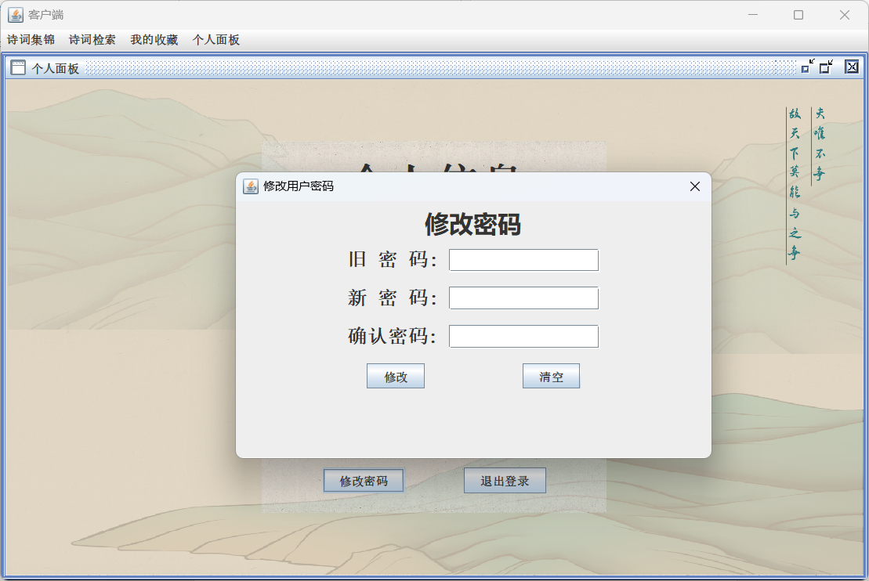

图2.6.2 修改密码功能

1. 代码实现：

**public class** userPersonalPanel **extends** JInternalFrame {  
  
 **public** userPersonalPanel() {  
 **super**(**"个人面板"**, **true**, **true**, **true**, **true**);  
  
 initCenter();  
  
 **try** {  
 setMaximum(**true**);  
 } **catch** (PropertyVetoException e) {  
 e.printStackTrace();  
 }  
 }  
  
 **private void** initCenter() {  
 JPanel center = **new** JPanel() {  
 @Override  
 **protected void** paintComponent(Graphics g) {  
 Graphics2D g2 = (Graphics2D) g;  
 g2.drawImage(**new** ImageIcon(SystemConstants.dir + **"bg1.png"**).getImage(), 0, 0, getWidth(), getHeight(), **null**);  
 }  
 };  
 center.setLayout(**new** GridBagLayout()); *// 使用GridBagLayout居中* JPanel panel = **new** JPanel() {  
 @Override  
 **protected void** paintComponent(Graphics g) {  
 Graphics2D g2 = (Graphics2D) g;  
 g2.drawImage(**new** ImageIcon(SystemConstants.dir + **"001.png"**).getImage(), 0, 0, getWidth(), getHeight(), **null**);  
 }  
 };  
 panel.setOpaque(**false**);  
 panel.setLayout(**new** BoxLayout(panel, BoxLayout.Y_AXIS)); *// 使用BoxLayout垂直排列  
  
// Administrator admin = DataSelece.findByAdminID(SystemConstants.currentID);* User user = DataSelece.findByUserID(SystemConstants.currentID);  
 **assert** user != **null**;  
  
  
 Box box = Box.createVerticalBox();  
 box.setBorder(BorderFactory.createEmptyBorder(20, 20, 20, 20));  
  
 Font labelFont = **new** Font(**"宋体"**, Font.BOLD, 32);  
 Font valueFont = **new** Font(**"宋体"**, Font.BOLD, 32);  
  
 JLabel title = **new** JLabel(**"个人信息"**);  
 title.setFont(**new** Font(**"宋体"**, Font.BOLD, 45));  
 title.setAlignmentX(Component.CENTER_ALIGNMENT); *// 标题居中对齐* box.add(title);  
 box.add(Box.createVerticalStrut(20));  
 box.add(createBox(**"身 份:"**, **"普通用户"**, labelFont, valueFont));  
 box.add(createBox(**"I D:"**, String.valueOf(user.getId()), labelFont, valueFont));  
 box.add(createBox(**"用户名:"**, user.getName(), labelFont, valueFont));  
 box.add(createBox(**"密 码:"**, user.getPassword(), labelFont, valueFont));  
 box.add(createBox(**"电 话:"**, user.getTelephone(), labelFont, valueFont));  
 box.add(createBox(**"收藏数:"**, **""** + user.getSatrs(), labelFont, valueFont));  
 box.add(Box.createVerticalStrut(20));  
 Box boxBtu = Box.createHorizontalBox();  
 JButton change = **new** JButton(**"修改密码"**);  
 JButton logOut = **new** JButton(**"退出登录"**);  
 logOut.addMouseListener(**new** MouseAdapter() {  
 @Override  
 **public void** mouseClicked(MouseEvent e) {  
 logout();  
 }  
 });  
  
 change.addMouseListener(**new** MouseAdapter() {  
 @Override  
 **public void** mouseClicked(MouseEvent e) {  
 **new** ModifyUserPasswordDialog(getParentJFrame(), SystemConstants.currentID).setVisible(**true**);  
  
 }  
 });  
 boxBtu.add(change);  
 boxBtu.add(Box.createHorizontalStrut(60));  
 boxBtu.add(logOut);  
  
 box.add(boxBtu);  
 panel.add(box);  
  
 GridBagConstraints gbc = **new** GridBagConstraints();  
 gbc.gridx = 0;  
 gbc.gridy = 0;  
 gbc.anchor = GridBagConstraints.CENTER;  
 center.add(panel, gbc);  
  
 **this**.add(center);  
 }  
 **private** Box createBox(String labelText, String valueText, Font labelFont, Font valueFont) {  
 Box box = Box.createHorizontalBox();  
 JLabel label = **new** JLabel(labelText);  
 label.setFont(labelFont);  
 JLabel value = **new** JLabel(valueText);  
 value.setFont(valueFont);  
 value.setForeground(Color.BLUE);  
 box.add(label);  
 box.add(Box.createHorizontalStrut(10)); *// 添加一个水平间隔* box.add(value);  
 box.add(Box.createVerticalStrut(20)); *// 添加一个垂直间隔* **return** box;  
 }  
 *// 退出登录* **private void** logout() {  
 SwingUtilities.getWindowAncestor(**this**).dispose(); *// 关闭当前窗口* JFrame mainFrame = **new** MainFrame(); *// 创建 MainFrame 界面* mainFrame.setVisible(**true**); *// 显示 MainFrame 界面* }  
  
 *// 获取主JFrame* **private** JFrame getParentJFrame() {  
 Container parent = **this**.getParent();  
 **while** (parent != **null**) {  
 **if** (parent **instanceof** JFrame) {  
 **return** (JFrame) parent;  
 }  
 parent = parent.getParent();  
 }  
 **return null**;  
 }  
}

修改密码功能实现：

**package** frame.user;  
**import** database.DataSelece;  
**import** database.DataUpdate;  
**import** javax.swing.*;  
**import** java.awt.*;  
**import** java.awt.event.MouseAdapter;  
**import** java.awt.event.MouseEvent;  
**public class** ModifyUserPasswordDialog **extends** JDialog {  
 **public** ModifyUserPasswordDialog(Frame owner, **int** id) {  
 **super**(owner, **"修改用户密码"**, **true**); *// true 表示模态对话框* initDialog(id);  
 }  
 JPasswordField **oldPasswordField**;  
 JPasswordField **newPasswordField**;  
 JPasswordField **newPasswordField2**;  
 **private void** initDialog(**int** id) {  
 *// 设置对话框的大小* **this**.setSize(500, 300);  
 *// 获取屏幕大小* Dimension screenSize = Toolkit.*getDefaultToolkit*().getScreenSize();  
 *// 计算对话框应居中的位置* **int** x = (screenSize.**width** - **this**.getWidth()) / 2;  
 **int** y = (screenSize.**height** - **this**.getHeight()) / 2;  
 *// 设置对话框的位置* **this**.setLocation(x, y);  
 JPanel south = **new** JPanel();  
 JLabel southLabel = **new** JLabel(**"修改密码"**);  
 Font font = **new** Font(**"微软雅黑"**, Font.***BOLD***, 25);  
 southLabel.setFont(font);  
 south.add(southLabel);  
 **this**.add(south, BorderLayout.***NORTH***);  
 JPanel jPanel = **new** JPanel();  
 Box box = Box.*createVerticalBox*();  
 Font boxFont = **new** Font(**"宋体"**, Font.***BOLD***, 20);  
 *// 添加标题* Box box1 = Box.*createHorizontalBox*();  
 JLabel titleLabel = **new** JLabel(**"旧 密 码:"**);  
 titleLabel.setFont(boxFont);  
 **oldPasswordField** = **new** JPasswordField(15);  
 box1.add(titleLabel);  
 box1.add(Box.*createHorizontalStrut*(10));  
 box1.add(**oldPasswordField**);  
 box.add(box1);  
 box.add(Box.*createVerticalStrut*(15));  
 *// 添加作者* Box box2 = Box.*createHorizontalBox*();  
 JLabel passLabel = **new** JLabel(**"新 密 码:"**);  
 passLabel.setFont(boxFont);  
 **newPasswordField** = **new** JPasswordField(15);  
 box2.add(passLabel);  
 box2.add(Box.*createHorizontalStrut*(10));  
 box2.add(**newPasswordField**);  
 box.add(box2);  
 box.add(Box.*createVerticalStrut*(15));  
 Box box3 = Box.*createHorizontalBox*();  
 JLabel telLabel = **new** JLabel(**"确认密码:"**);  
 telLabel.setFont(boxFont);  
 **newPasswordField2** = **new** JPasswordField(15);  
 box3.add(telLabel);  
 box3.add(Box.*createHorizontalStrut*(10));  
 box3.add(**newPasswordField2**);  
 box.add(box3);  
 box.add(Box.*createVerticalStrut*(15));  
 Box boxButton = Box.*createHorizontalBox*();  
 JButton updateBut = **new** JButton(**"修改"**);  
 JButton clearBut = **new** JButton(**"清空"**);  
 updateBut.addMouseListener(**new** MouseAdapter() {  
 @Override  
 **public void** mouseClicked(MouseEvent e) {  
 updatePassword(id);  
 }  
 });  
 clearBut.addMouseListener(**new** MouseAdapter() {  
 @Override  
 **public void** mouseClicked(MouseEvent e) {  
 clearText();  
 }  
 });  
 boxButton.add(updateBut);  
 boxButton.add(Box.*createHorizontalStrut*(100));  
 boxButton.add(clearBut);  
 box.add(boxButton);  
 jPanel.add(box, BorderLayout.***CENTER***);  
 **this**.add(jPanel, BorderLayout.***CENTER***);  
 *// 设置对话框的默认关闭操作* **this**.setDefaultCloseOperation(JDialog.***DISPOSE_ON_CLOSE***);  
 }  
 **private void** updatePassword(**int** id){  
 String old = **new** String(**oldPasswordField**.getPassword());  
 String new1 = **new** String(**newPasswordField**.getPassword());  
 String new2 = **new** String(**newPasswordField2**.getPassword());  
 String oldSurePassword = DataSelece.*getPasswordByID*(id, **true**);  
*// System.out.println(oldSurePassword);* **if** (!old.equals(oldSurePassword)) {  
 JOptionPane.*showMessageDialog*(**this**, **"密码错误"**, **"提示"**, JOptionPane.***WARNING_MESSAGE***);  
 **return** ;  
 }  
 **if** (old.isEmpty()) {  
 JOptionPane.*showMessageDialog*(**this**, **"用户名不得为空"**, **"提示"**, JOptionPane.***WARNING_MESSAGE***);  
 **return**;  
 }  
 **if** (new1.isEmpty()) {  
 JOptionPane.*showMessageDialog*(**this**, **"密码不得为空"**, **"提示"**, JOptionPane.***WARNING_MESSAGE***);  
 **return**;  
 }  
 **if** (!new1.equals(new2)){  
 JOptionPane.*showMessageDialog*(**this**, **"两次输入密码不一致"**, **"提示"**, JOptionPane.***WARNING_MESSAGE***);  
 **return**;  
 }  
 DataUpdate.*updateUserPassword*(id, new1);  
 JOptionPane.*showMessageDialog*(**this**, **"修改成功"**, **"提示"**, JOptionPane.***WARNING_MESSAGE***);  
 }  
  
 **private void** clearText(){  
 **oldPasswordField**.setText(**""**);  
 **newPasswordField**.setText(**""**);  
 **newPasswordField2**.setText(**""**);  
 }  
  
}

### 2.3.7 管理端-诗词管理功能实现

诗词管理界面，可以实现对诗词的全部检索，添加诗词，修改诗词，删除诗词的功能。单击全部检索，在表格中显示所有的诗词。单击添加诗词，弹出一个JDialog界面，引导添加诗词，其中，标题、作者可以为空，若为空，则自动填充为“无题”、“佚名”。朝代、类型、内容不得为空，若为空，则弹出提示---“朝代不得为空”、“类型不得为空”、“内容不得为空”。朝代与类型可以通过下拉框进行选择。添加成功后，提示“添加成功”。同时，可以通过单击清空按钮实现清空文本框内的数据。单击修改诗词，则打开JDialog界面，并将选中的诗词内容输入到文本框，若未选择诗词，则提示“请选择要修改的内容”。单击删除诗词，若有选择，则弹出确认框“是否确认删除选中的x条数据”（其中，x为选中的内容条数），若单击确定，则成功删除，单击取消，则终止删除，若为选择任何诗词，则弹出提示“请先选择内容”。同时，支持多条件模糊查询。

（1）界面截图

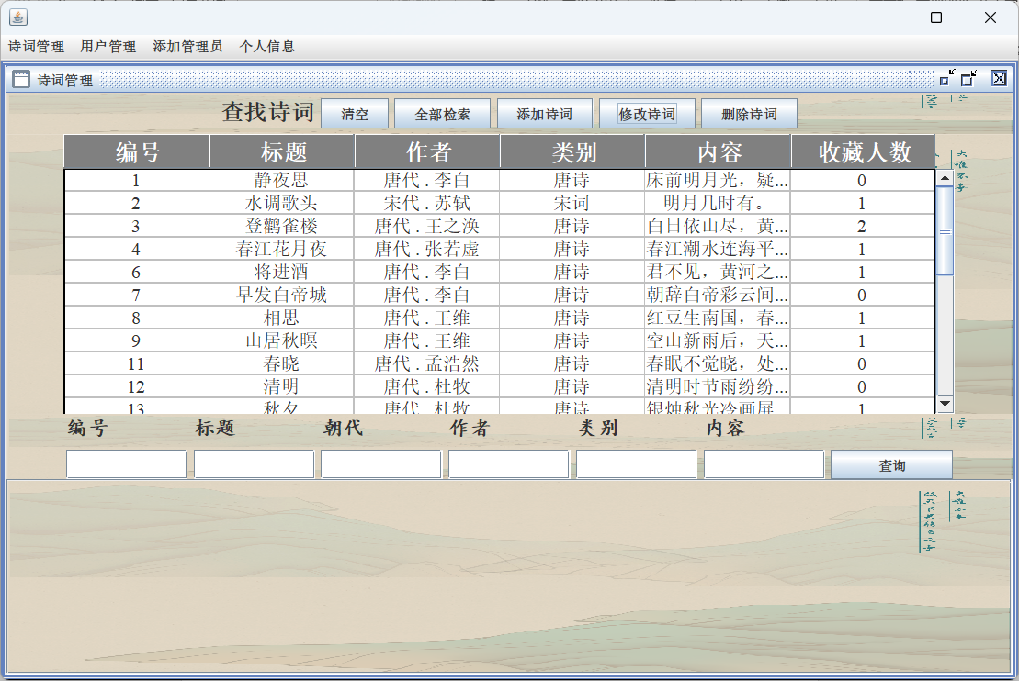

图2.7.1 诗词管理界面

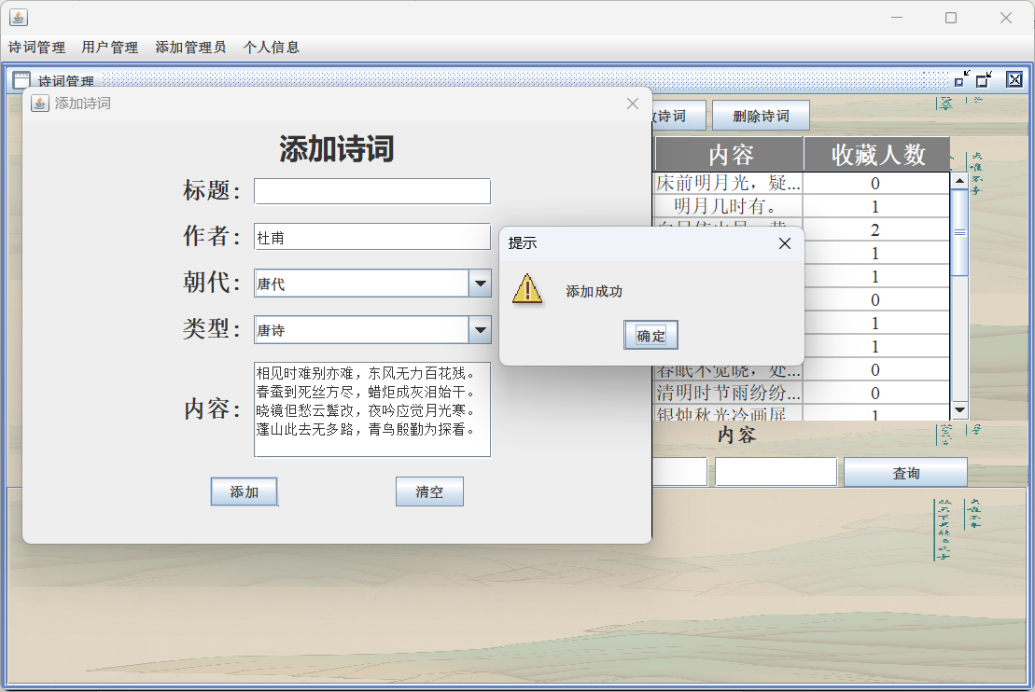

图2.7.2添加成功

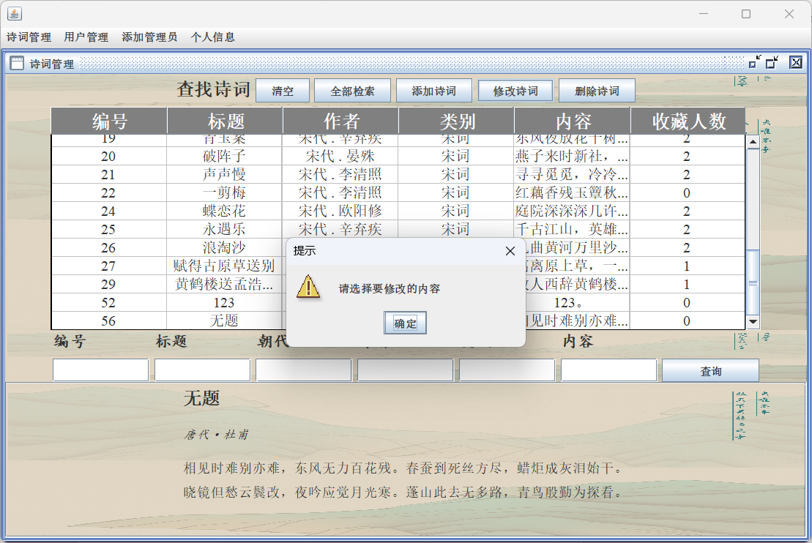

图2.7.3 修改诗词（未选择诗词）

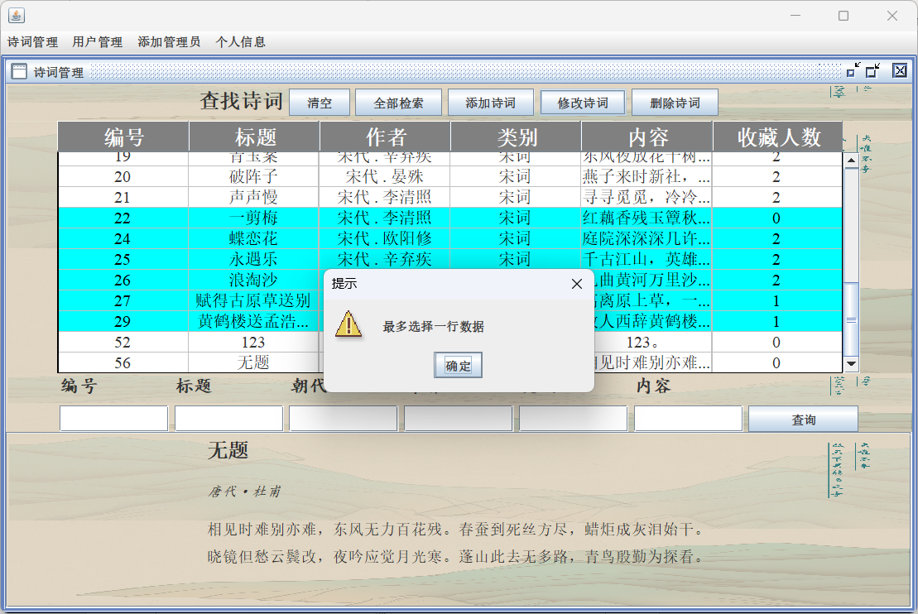

图2.7.4 修改诗词 选中多行数据

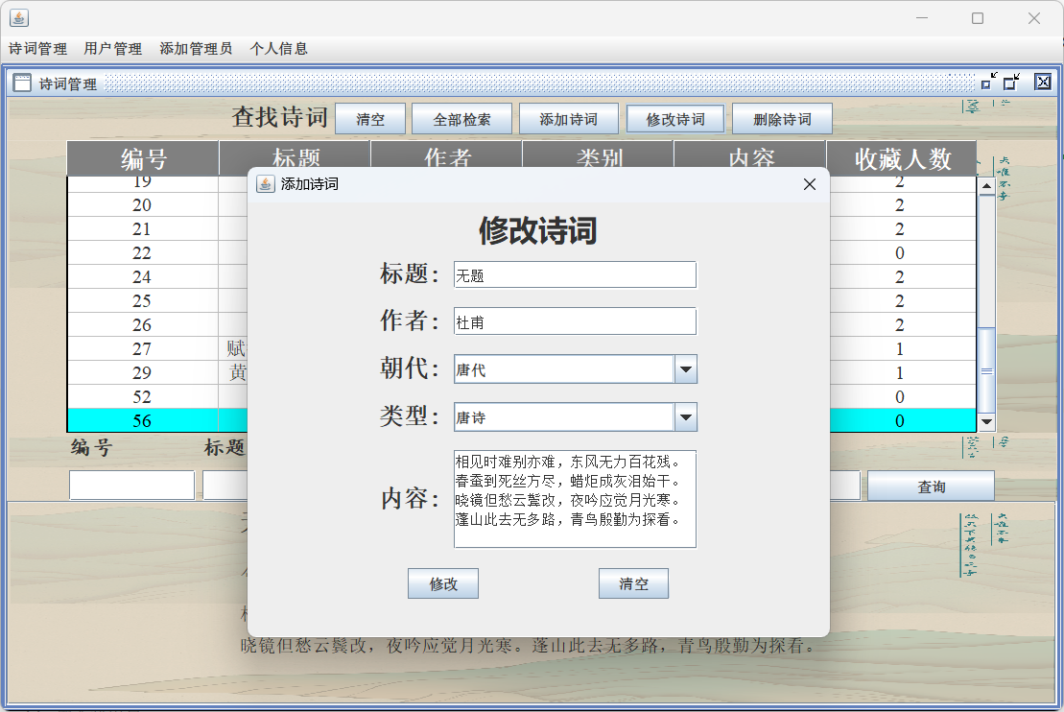

图2.7.5 修改诗词（正常操作）

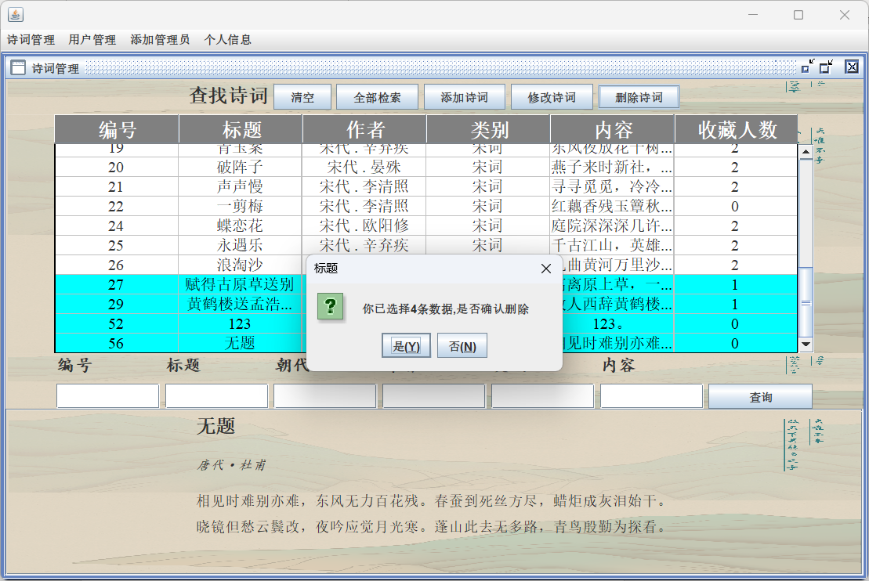

图2.7.6 删除诗词

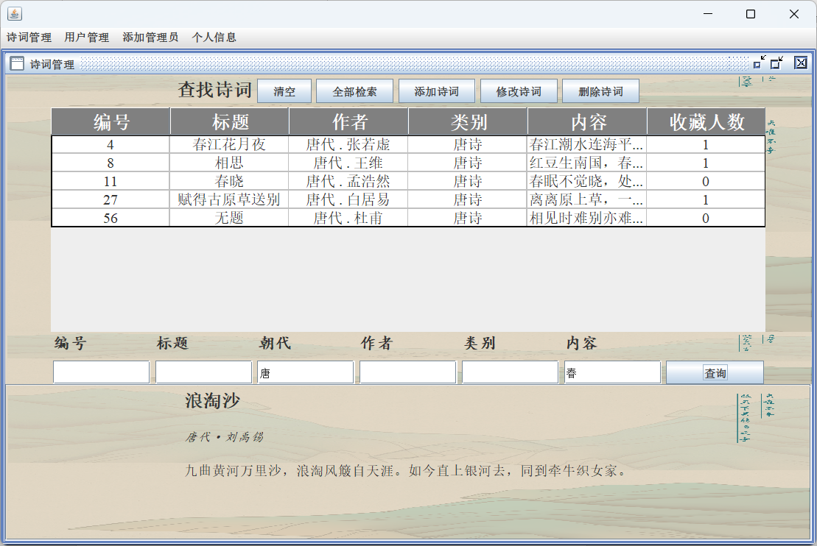

图2.7.7 多条件模糊查询

（2）代码实现

界面绘制代码不再展示，仅展示实现逻辑功能的函数：

主界面逻辑函数：

**private void** findPoetry(String newId, String newTitle, String newDynast, String newAuthor,  
 String newType, String newText){  
 ArrayList<Poetry> poetries = DataSelece.FindByCriteria(newId, newTitle, newDynast, newAuthor, newType, newText);  
 tableModel.setRowCount(0);  
 **for** (Poetry p:poetries) {  
 String dynast = p.getDynasty() +**" . "** + p.getAuthor();  
 **int** stars = DataSelece.getStarNumber(p.getPoetry_id());  
 Object[] rowData = {p.getPoetry_id(), p.getTitle(), dynast, p.getType(), p.getText()[0], stars};  
 tableModel.addRow(rowData);  
 }  
}  
*// 打开添加诗词面板***private void** AddPoetry(){  
 **new** AddPoetryDialog(getParentJFrame()).setVisible(**true**);  
 refreshTable();  
}  
*// 获取当前界面所归属JFrame类***private** JFrame getParentJFrame() {  
 Container parent = **this**.getParent();  
 **while** (parent != **null**) {  
 **if** (parent **instanceof** JFrame) {  
 **return** (JFrame) parent;  
 }  
 parent = parent.getParent();  
 }  
 **return null**;  
}  
*// 删除诗词***private void** DeletePoetry(){  
 **int**[] selectRows = jTable.getSelectedRows();  
 **if** (selectRows.length == 0) {  
 JOptionPane.showMessageDialog(**this**, **"请先选中内容"**, **"提示"**, JOptionPane.WARNING_MESSAGE);  
 **return**;  
 } **else** {  
 *// 返回值, 是返回0, 否返回1, 取消返回2, 直接关闭返回-1* **int** res = JOptionPane.showConfirmDialog(**this**, **"你已选择"** + selectRows.length + **"条数据,是否确认删除"**, **"标题"**, JOptionPane.YES_NO_OPTION);  
 **if** (res != 0) **return**;  
 }  
 **for**(**int** x:selectRows){  
 **int** id = getSelectPoetrID(x); *// 获取选中列的id* DataDelete.PoetryDelete(id); *// 删除信息* }  
 refreshTable();  
}  
*// 更新诗词***private void** UpdatePoetry(){  
 **int**[] selectRows = jTable.getSelectedRows();  
 **if** (selectRows.length == 0) {  
 JOptionPane.showMessageDialog(**this**, **"请选择要修改的内容"**, **"提示"**, JOptionPane.WARNING_MESSAGE);  
 **return**;  
 }  
 **if** (selectRows.length > 1) {  
 JOptionPane.showMessageDialog(**this**, **"最多选择一行数据"**, **"提示"**, JOptionPane.WARNING_MESSAGE);  
 **return**;  
 }  
 **int** id = getSelectPoetrID(selectRows[0]); *// 获取选中列的id* **new** ModifyPoetryDialog(getParentJFrame(), id).setVisible(**true**);  
 refreshTable();  
}  
*// 美化表格***private void** beautiful(){  
 *// 设置表格的字体和行高：* jTable.setFont(**new** Font(**"Serif"**, Font.PLAIN, 16));  
 jTable.setRowHeight(20);  
 *// 自定义表头的样式：* JTableHeader tableHeader = jTable.getTableHeader();  
 tableHeader.setFont(**new** Font(**"SansSerif"**, Font.BOLD, 20));  
 tableHeader.setBackground(Color.GRAY);  
 tableHeader.setForeground(Color.WHITE);  
 *// 自定义单元格渲染器：* jTable.setGridColor(Color.LIGHT_GRAY);  
 *// 自定义单元格渲染器：* DefaultTableCellRenderer centerRenderer = **new** DefaultTableCellRenderer();  
 centerRenderer.setHorizontalAlignment(SwingConstants.CENTER);  
 **for** (**int** i = 0; i < jTable.getColumnCount(); i++) {  
 jTable.getColumnModel().getColumn(i).setCellRenderer(centerRenderer);  
 }  
 *// 设置选中颜色* jTable.setSelectionBackground(Color.CYAN);  
 jTable.setSelectionForeground(Color.BLACK);  
}

添加诗词（JDialog）:

**package** frame.admin.Dialog;  
  
**import** database.DataInsert;  
  
**import** javax.swing.*;  
**import** java.awt.*;  
**import** java.awt.event.MouseAdapter;  
**import** java.awt.event.MouseEvent;  
**import** java.util.Objects;  
  
**public class** AddPoetryDialog **extends** JDialog {  
 **public** AddPoetryDialog(Frame owner) {  
 **super**(owner, **"添加诗词"**, **true**); *// true 表示模态对话框* initDialog();  
 }  
 JTextField titleField;  
 JTextField authorField;  
 JComboBox<String> dynastyComboBox;  
 JComboBox<String> typeComboBox;  
 JTextArea textArea;  
 **private void** initDialog() {  
 *// 设置对话框的大小* **this**.setSize(500, 400);  
 *// 获取屏幕大小* Dimension screenSize = Toolkit.getDefaultToolkit().getScreenSize();  
 *// 计算对话框应居中的位置* **int** x = (screenSize.width - **this**.getWidth()) / 2;  
 **int** y = (screenSize.height - **this**.getHeight()) / 2;  
 *// 设置对话框的位置* **this**.setLocation(x, y);  
 JPanel south = **new** JPanel();  
 JLabel southLabel = **new** JLabel(**"添加诗词"**);  
 Font font = **new** Font(**"微软雅黑"**, Font.BOLD, 25);  
 southLabel.setFont(font);  
 south.add(southLabel);  
 **this**.add(south, BorderLayout.NORTH);  
 JPanel jPanel = **new** JPanel();  
 Box box = Box.createVerticalBox();  
 Font boxFont = **new** Font(**"宋体"**, Font.BOLD, 20);  
 *// 添加标题* Box box1 = Box.createHorizontalBox();  
 JLabel titleLabel = **new** JLabel(**"标题:"**);  
 titleLabel.setFont(boxFont);  
 titleField = **new** JTextField(20);  
 box1.add(titleLabel);  
 box1.add(Box.createHorizontalStrut(10));  
 box1.add(titleField);  
 box.add(box1);  
 box.add(Box.createVerticalStrut(15));  
 *// 添加作者* Box box2 = Box.createHorizontalBox();  
 JLabel authorLabel = **new** JLabel(**"作者:"**);  
 authorLabel.setFont(boxFont);  
 authorField = **new** JTextField(20);  
 box2.add(authorLabel);  
 box2.add(Box.createHorizontalStrut(10));  
 box2.add(authorField);  
 box.add(box2);  
 box.add(Box.createVerticalStrut(15));  
 *// 创建可编辑的下拉选择框* String[] dynasties = {**"唐代"**, **"宋代"**, **"元代"**, **"现代"**};  
 dynastyComboBox = **new** JComboBox<>(dynasties);  
 dynastyComboBox.setEditable(**true**); *// 允许用户自定义输入* dynastyComboBox.setPreferredSize(**new** Dimension(200, dynastyComboBox.getPreferredSize().height));  
 *// 添加朝代* Box box3 = Box.createHorizontalBox();  
 JLabel dynastyLabel = **new** JLabel(**"朝代:"**);  
 dynastyLabel.setFont(boxFont);  
 box3.add(dynastyLabel);  
 box3.add(Box.createHorizontalStrut(10));  
 box3.add(dynastyComboBox);  
 box.add(box3);  
 box.add(Box.createVerticalStrut(15));  
 dynastyComboBox.setSelectedItem(**null**);  
 *// 创建可编辑的下拉选择框* String[] types = {**"唐诗"**, **"宋词"**, **"元曲"**, **"现代诗"**, **"先秦文学"**, **"暂无归类"**};  
 typeComboBox = **new** JComboBox<>(types);  
 typeComboBox.setEditable(**true**); *// 允许用户自定义输入* typeComboBox.setPreferredSize(**new** Dimension(200, typeComboBox.getPreferredSize().height));  
 *// 添加类别* Box box4 = Box.createHorizontalBox();  
 JLabel typeLabel = **new** JLabel(**"类型:"**);  
 typeLabel.setFont(boxFont);  
 box4.add(typeLabel);  
 box4.add(Box.createHorizontalStrut(10));  
 box4.add(typeComboBox);  
 box.add(box4);  
 box.add(Box.createVerticalStrut(15));  
 typeComboBox.setSelectedItem(**null**);  
 *// 创建文本域* textArea = **new** JTextArea(5, 20);  
 textArea.setLineWrap(**true**); *// 自动换行* textArea.setWrapStyleWord(**true**); *// 换行不断字  
 // 将文本区域放入滚动面板中* JScrollPane scrollPane = **new** JScrollPane(textArea,  
 JScrollPane.VERTICAL_SCROLLBAR_AS_NEEDED, JScrollPane.HORIZONTAL_SCROLLBAR_NEVER);  
 *// 添加正文* Box box5 = Box.createHorizontalBox();  
 JLabel textLabel = **new** JLabel(**"内容:"**);  
 textLabel.setFont(boxFont);  
 box5.add(textLabel);  
 box5.add(Box.createHorizontalStrut(10));  
 box5.add(scrollPane);  
 box.add(box5);  
 box.add(Box.createVerticalStrut(15));  
  
 Box boxButton = Box.createHorizontalBox();  
 JButton addBut = **new** JButton(**"添加"**);  
 JButton clearBut = **new** JButton(**"清空"**);  
 addBut.addMouseListener(**new** MouseAdapter() {  
 @Override  
 **public void** mouseClicked(MouseEvent e) {  
 addPoetry();  
 }  
 });  
 clearBut.addMouseListener(**new** MouseAdapter() {  
 @Override  
 **public void** mouseClicked(MouseEvent e) {  
 clearText();  
 }  
 });  
 boxButton.add(addBut);  
 boxButton.add(Box.createHorizontalStrut(100));  
 boxButton.add(clearBut);  
 box.add(boxButton);  
 jPanel.add(box, BorderLayout.CENTER);  
 **this**.add(jPanel, BorderLayout.CENTER);  
 *// 设置对话框的默认关闭操作* **this**.setDefaultCloseOperation(JDialog.DISPOSE_ON_CLOSE);  
 }  
 **private void** addPoetry(){  
 String title = titleField.getText();  
 String author = authorField.getText();  
 String dynasty = (String) dynastyComboBox.getSelectedItem();  
 String type = (String) typeComboBox.getSelectedItem();  
 String text = textArea.getText().trim();  
 **if** (dynasty == **null**) {  
 JOptionPane.showMessageDialog(**this**, **"朝代不得为空"**, **"提示"**, JOptionPane.WARNING_MESSAGE);  
 **return**;  
 }  
 **if** (type == **null**) {  
 JOptionPane.showMessageDialog(**this**, **"类别不得为空"**, **"提示"**, JOptionPane.WARNING_MESSAGE);  
 **return**;  
 }  
 **if** (text.isEmpty()) {  
 JOptionPane.showMessageDialog(**this**, **"请输入文本"**, **"提示"**, JOptionPane.WARNING_MESSAGE);  
 **return**;  
 }  
 System.out.println(**"标题: "** + title);  
 System.out.println(**"作者: "** + author);  
 System.out.println(**"朝代: "** + dynasty);  
 System.out.println(**"类别: "** + type);  
 System.out.println(**"文本: "** + text);  
  
 DataInsert.PoetryInsert(title, author, dynasty, type, text);  
  
 JOptionPane.showMessageDialog(**this**, **"添加成功"**, **"提示"**, JOptionPane.WARNING_MESSAGE);  
 }  
 **private void** clearText(){  
 titleField.setText(**""**);  
 authorField.setText(**""**);  
 dynastyComboBox.setSelectedIndex(-1);  
 typeComboBox.setSelectedItem(**null**);  
 textArea.setText(**""**);  
 }

修改诗词（JDialog，只提供逻辑功能函数）：

**private void** updatePoetry(**int** id){  
 String title = titleField.getText();  
 String author = authorField.getText();  
 String dynasty = (String) dynastyComboBox.getSelectedItem();  
 String type = (String) typeComboBox.getSelectedItem();  
 String text = textArea.getText().trim();  
  
 **if** (dynasty == **null**) {  
 JOptionPane.showMessageDialog(**this**, **"朝代不得为空"**, **"提示"**, JOptionPane.WARNING_MESSAGE);  
 **return**;  
 }  
 **if** (type == **null**) {  
 JOptionPane.showMessageDialog(**this**, **"类别不得为空"**, **"提示"**, JOptionPane.WARNING_MESSAGE);  
 **return**;  
 }  
 **if** (text.isEmpty()) {  
 JOptionPane.showMessageDialog(**this**, **"请输入文本"**, **"提示"**, JOptionPane.WARNING_MESSAGE);  
 **return**;  
 }  
 System.out.println(**"标题: "** + title);  
 System.out.println(**"作者: "** + author);  
 System.out.println(**"朝代: "** + dynasty);  
 System.out.println(**"类别: "** + type);  
 System.out.println(**"文本: "** + text);

DataUpdate.PoetryUpdate(id, title, author, dynasty, type, text);

JOptionPane.showMessageDialog(**this**, **"修改成功"**, **"提示"**, JOptionPane.WARNING_MESSAGE);  
  
 *// 关闭面板* dispose();  
}  
**private void** clearText(){  
 titleField.setText(**""**);  
 authorField.setText(**""**);  
 dynastyComboBox.setSelectedIndex(-1);  
 typeComboBox.setSelectedItem(**null**);  
 textArea.setText(**""**);  
}  
  
**private void** setAllField(**int** id){  
  
 Poetry poetry = DataSelece.IDtoPoetry(id);  
  
 **assert** poetry != **null**;  
 titleField.setText(poetry.getTitle());  
 authorField.setText(poetry.getAuthor());  
 dynastyComboBox.setSelectedItem(poetry.getDynasty());  
 typeComboBox.setSelectedItem(poetry.getType());  
 textArea.setText(StrstoString(poetry.getText()));  
}  
  
**private** String StrstoString(String[] strs){  
 StringBuilder ans = **new** StringBuilder();  
 **for** (String s:strs){  
 ans.append(s).append(**"\n"**);  
 }  
 **return** ans.toString();  
}

### 2.3.8 管理端-用户管理的实现

用户管理界面提供了用户查询功能，可以通过用户ID进行精确查找，也可以通过用户名以及用户手机号进行模糊查找。可以通过鼠标选择删除用户，删除是必须要选中要删除的内容，若未选中则弹出提示“请选择要删除的内容”， 选择用户数据并点击删除后，弹出确认菜单“是否确认删除x条数据”{其中x为选中的数据条数}，若单击确定，则执行删除操作。单击添加用户，或修改用户，弹出JDialog菜单，进行操作，其中，用户名或密码为空均会弹出提示。同时，增添是否显示密码组件，若选中该组件，则用户密码正常显示，否则则以“********”替代。

1. 界面截图：

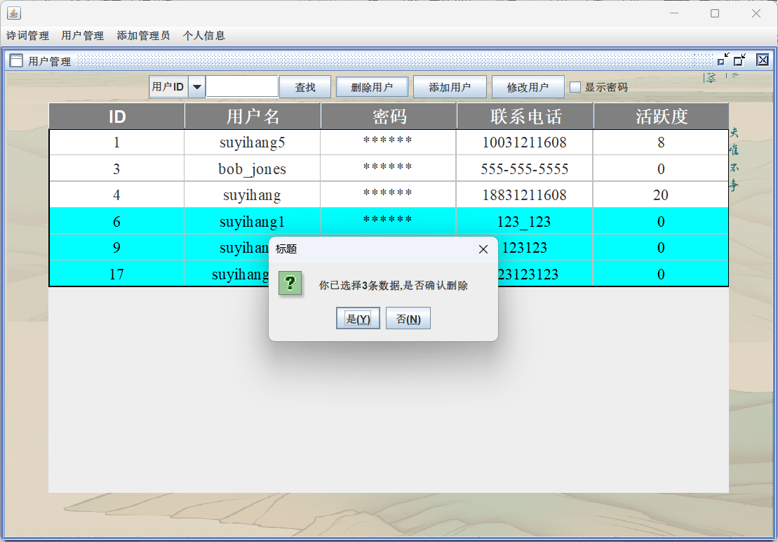

图2.8.1 执行删除用户操作

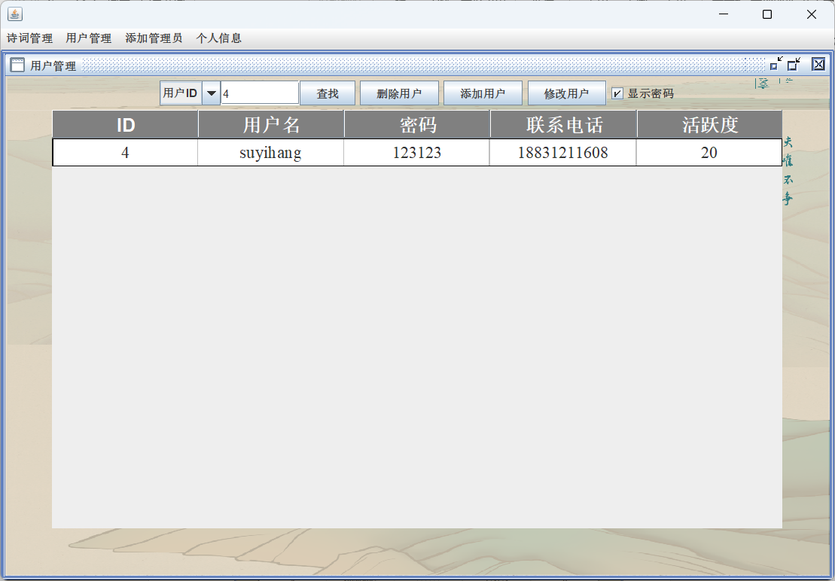

图2.8.2 按用户ID进行查找（显示密码）

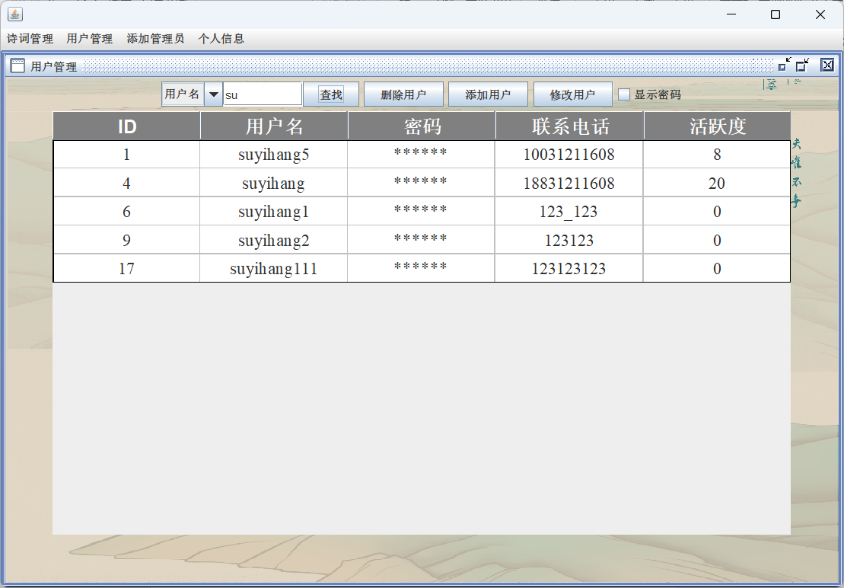

图2.8.3 按用户名进行模糊搜索（不显示密码）

1. 代码实现

**package** frame.admin;

**import** database.DataDelete;  
**import** database.DataSelece;  
**import** frame.admin.Dialog.AddUserDialog;  
**import** frame.admin.Dialog.ModifyUserDialog;  
**import** pojo.User;  
**import** util.SystemConstants;  
  
**public class** UserManage **extends** JInternalFrame {  
 **public** UserManage() {  
 **super**(**"用户管理"**, **true**, **true**, **true**, **true**);  
 setMaximizable(**true**);  
 initNorth();  
 initCenter();  
*// initSouth();* **try** {  
 setMaximum(**true**);  
 } **catch** (PropertyVetoException e) {  
 e.printStackTrace();  
 }  
 }  
 JComboBox<String> **comboBox**;  
 JTextField **jTextField**;  
 JButton **selectBtu**;  
 JButton **deleteBtu**;  
 JButton **addBtu**;  
 JButton **modifyBtu**;  
 JCheckBox **checkBox**;  
  
 **private void** initNorth() {  
  
 JPanel north = **new** JPanel(**new** FlowLayout()){  
 @Override  
 **protected void** paintComponent(Graphics g){  
 Graphics2D g2 = (Graphics2D) g;  
 g2.drawImage(**new** ImageIcon(SystemConstants.***dir*** + **"bg1.png"**).getImage(), 0, 0,getWidth(), getHeight(), **null**);  
 }  
 };  
  
 Box box = Box.*createHorizontalBox*();  
 String[] items = {**"用户ID"**, **"用户名"**, **"密码"**, **"电话"**};  
 **comboBox** = **new** JComboBox<>(items);  
 **jTextField** = **new** JTextField(8);  
 **selectBtu** = **new** JButton(**"查找"**);  
  
 **selectBtu**.addMouseListener(**new** MouseAdapter() {  
 @Override  
 **public void** mouseClicked(MouseEvent e) {  
 refresh();  
 }  
 });  
  
 box.add(**comboBox**);  
 box.add(**jTextField**);  
 box.add(**selectBtu**);  
  
 **deleteBtu** = **new** JButton(**"删除用户"**);  
 **addBtu** = **new** JButton(**"添加用户"**);  
 **modifyBtu** = **new** JButton(**"修改用户"**);  
 **checkBox** = **new** JCheckBox(**"显示密码"**);  
  
 **checkBox**.addActionListener(**new** ActionListener() {  
 @Override  
 **public void** actionPerformed(ActionEvent e) {  
 refresh();  
 }  
 });  
  
 **addBtu**.addMouseListener(**new** MouseAdapter() {  
 @Override  
 **public void** mouseClicked(MouseEvent e) {  
 AddUser();  
 }  
 });  
  
 **deleteBtu**.addMouseListener(**new** MouseAdapter() {  
 @Override  
 **public void** mouseClicked(MouseEvent e) {  
 DeleteUser();  
 }  
 });  
  
 **modifyBtu**.addMouseListener(**new** MouseAdapter() {  
 @Override  
 **public void** mouseClicked(MouseEvent e) {  
 updateUser();  
 }  
 });  
  
 *// 设置背景透明* **checkBox**.setOpaque(**false**);  
  
 *// 取消选择时的黑色边框* **checkBox**.setBorderPainted(**false**);  
  
 *// 自定义选中和未选中状态的颜色（可选）* **checkBox**.setFocusPainted(**false**); *// 去掉焦点虚线框* **checkBox**.setContentAreaFilled(**false**); *// 去掉内容填充* **checkBox**.setBorder(**null**); *// 去掉边框* north.add(box);  
 north.add(**deleteBtu**);  
 north.add(**addBtu**);  
 north.add(**modifyBtu**);  
 north.add(**checkBox**);  
  
 **this**.add(north, BorderLayout.***NORTH***);  
 }  
  
 *// 表格中的数据* Object[][] **data** = {};  
 DefaultTableModel **tableModel**;  
 JTable **jTable**;  
  
 **private void** initCenter() {  
 Object[] cloumnNames = {**"ID"**, **"用户名"**, **"密码"**, **"联系电话"**, **"活跃度"**};  
  
 **tableModel** = **new** DefaultTableModel(**data**, cloumnNames) {  
 @Override  
 **public boolean** isCellEditable(**int** row, **int** column) {  
 *// 所有单元格都不可编辑* **return false**;  
 }  
 };  
 **jTable** = **new** JTable(**tableModel**);  
 JScrollPane center = **new** JScrollPane(**jTable**){  
 @Override  
 **protected void** paintComponent(Graphics g){  
 Graphics2D g2 = (Graphics2D) g;  
 g2.drawImage(**new** ImageIcon(SystemConstants.***dir*** + **"bg1.png"**).getImage(), 0, 0,getWidth(), getHeight(), **null**);  
 }  
 };  
  
 **jTable**.setSelectionMode(ListSelectionModel.***SINGLE_INTERVAL_SELECTION***);  
  
 **jTable**.setBorder(BorderFactory.*createLineBorder*(Color.***BLACK***));  
 *// 添加边框线* center.setBorder(BorderFactory.*createLineBorder*(Color.***BLACK***));  
 *// 设置页边距* center.setBorder(**new** EmptyBorder(0, 50, 50, 50));  
  
 *// 设置表格的字体和行高：* **jTable**.setFont(**new** Font(**"Serif"**, Font.***PLAIN***, 18));  
 **jTable**.setRowHeight(30);  
 *// 自定义表头的样式：* JTableHeader tableHeader = **jTable**.getTableHeader();  
 tableHeader.setFont(**new** Font(**"SansSerif"**, Font.***BOLD***, 20));  
 tableHeader.setBackground(Color.***GRAY***);  
 tableHeader.setForeground(Color.***WHITE***);  
 *// 自定义单元格渲染器：* **jTable**.setGridColor(Color.***LIGHT_GRAY***);  
 *// 自定义单元格渲染器：* DefaultTableCellRenderer centerRenderer = **new** DefaultTableCellRenderer();  
 centerRenderer.setHorizontalAlignment(SwingConstants.***CENTER***);  
 **for** (**int** i = 0; i < **jTable**.getColumnCount(); i++) {  
 **jTable**.getColumnModel().getColumn(i).setCellRenderer(centerRenderer);  
 }  
 *// 设置选中颜色* **jTable**.setSelectionBackground(Color.***CYAN***);  
 **jTable**.setSelectionForeground(Color.***BLACK***);  
  
  
 **this**.add(center, BorderLayout.***CENTER***);  
 }  
  
 *// 查找所有用户* **private void** findAllUsers(){  
 ArrayList<User> users = DataSelece.*getAllUsers*();  
 **tableModel**.setRowCount(0);  
 **for** (User user:users){  
 String password = **checkBox**.isSelected()? user.getPassword():**"******"**;  
 Object[] rowData = {user.getId(), user.getName(), password, user.getTelephone(), user.getSatrs()};  
 **tableModel**.addRow(rowData);  
 }  
 }  
 *// 查找用户* **private void** findUser(String item, String text){  
 ArrayList<User> users = DataSelece.*findUser*(item, text);  
 **tableModel**.setRowCount(0);  
 **for** (User user:users){  
 String password = **checkBox**.isSelected()? user.getPassword():**"******"**;  
 Object[] rowData = {user.getId(), user.getName(), password, user.getTelephone(), user.getSatrs()};  
 **tableModel**.addRow(rowData);  
 }  
 }  
 *// 刷新表格* **private void** refresh(){  
 **if** (**jTextField**.getText().isEmpty()){  
 findAllUsers();  
 } **else** {  
 findUser(Objects.*requireNonNull*(**comboBox**.getSelectedItem()).toString(), **jTextField**.getText());  
 }  
 }  
 *// 删除用户* **private void** DeleteUser() {  
 **int**[] selectRows = **jTable**.getSelectedRows();  
 **if** (selectRows.**length** == 0) {  
 JOptionPane.*showMessageDialog*(**this**, **"请先选中内容"**, **"提示"**, JOptionPane.***WARNING_MESSAGE***);  
 **return**;  
 } **else** {  
 *// 返回值, 是返回0, 否返回1, 取消返回2, 直接关闭返回-1* **int** res = JOptionPane.*showConfirmDialog*(**this**, **"你已选择"** + selectRows.**length** + **"条数据,是否确认删除"**, **"标题"**, JOptionPane.***YES_NO_OPTION***);  
 **if** (res != 0) **return**;  
 }  
 **for**(**int** x:selectRows){  
 **int** id = getSelectUserID(x); *// 获取选中列的id* DataDelete.*UserDelete*(id); *// 删除信息* }  
 refresh();  
 }  
 *// 获取选中的用户ID* **private int** getSelectUserID(**int** x) {  
 **if** (x < 0) **return** -1;  
 *// 获取表格模型* DefaultTableModel model = (DefaultTableModel) **jTable**.getModel();  
 *// 获取id* TableColumnModel columnModel = **jTable**.getColumnModel();  
 **int** columnIndexInView = columnModel.getColumnIndex(**"ID"**);  
 **int** columnIndexInModel = **jTable**.convertColumnIndexToModel(columnIndexInView);  
  
 **return** (**int**) model.getValueAt(x, columnIndexInModel);  
 }  
 *// debug* **public static void** main(String[] args) {  
 ArrayList<User> users = DataSelece.*getAllUsers*();  
 **for** (User user:users){  
 System.***out***.println(user.getId());  
 System.***out***.println(user.getName());  
 System.***out***.println(user.getPassword());  
 System.***out***.println(user.getTelephone());  
 System.***out***.println(user.getSatrs());  
 System.***out***.println();  
 }  
 }  
 *// 添加用户* **private void** AddUser(){  
 **new** AddUserDialog(getParentJFrame()).setVisible(**true**);  
 findAllUsers();  
 }  
 **private** JFrame getParentJFrame() {  
 Container parent = **this**.getParent();  
 **while** (parent != **null**) {  
 **if** (parent **instanceof** JFrame) {  
 **return** (JFrame) parent;  
 }  
 parent = parent.getParent();  
 }  
 **return null**;  
 }  
 *// 更新用户* **private void** updateUser(){  
 **int**[] selectRows = **jTable**.getSelectedRows();  
 **if** (selectRows.**length** == 0) {  
 JOptionPane.*showMessageDialog*(**this**, **"请选择要修改的内容"**, **"提示"**, JOptionPane.***WARNING_MESSAGE***);  
 **return**;  
 }  
 **if** (selectRows.**length** > 1) {  
 JOptionPane.*showMessageDialog*(**this**, **"最多选择一行数据"**, **"提示"**, JOptionPane.***WARNING_MESSAGE***);  
 **return**;  
 }  
 **int** id = getSelectuserID(selectRows[0]); *// 获取选中列的id* **new** ModifyUserDialog(getParentJFrame(), id).setVisible(**true**);  
 refresh();  
 }  
 *// 获取选中列的用户ID* **private int** getSelectuserID(**int** x) {  
 **if** (x < 0) **return** -1;  
 *// 获取表格模型* DefaultTableModel model = (DefaultTableModel) **jTable**.getModel();  
 *// 获取id* TableColumnModel columnModel = **jTable**.getColumnModel();  
 **int** columnIndexInView = columnModel.getColumnIndex(**"ID"**);  
 **int** columnIndexInModel = **jTable**.convertColumnIndexToModel(columnIndexInView);  
  
 **return** (**int**) model.getValueAt(x, columnIndexInModel);  
 }  
}

添加用户与修改用户代码省略，逻辑与添加与修改诗词代码相似。

### 3.2.9 管理端-添加管理员与个人面板

单击添加管理员选择，则弹出一个JDialog界面进行操作，其中，管理员用户名与密码不得为空，若为空则弹出提示“用户名\密码不得为空”，若管理员用户名重复，则弹出提示“用户名重复”，手机号与姓名设置可以为空。个人面板中展示当前登录账号的个人数据，其中报告修改密码与退出登录两项功能。单击修改密码则弹出JDialog界面进行操作。其中，限定旧密码必须输入正确，新密码与确认密码必须相同才可以正确修改，否则根据错误弹出相应提示。单击退出登录，则返回登录界面。

1. 页面截图

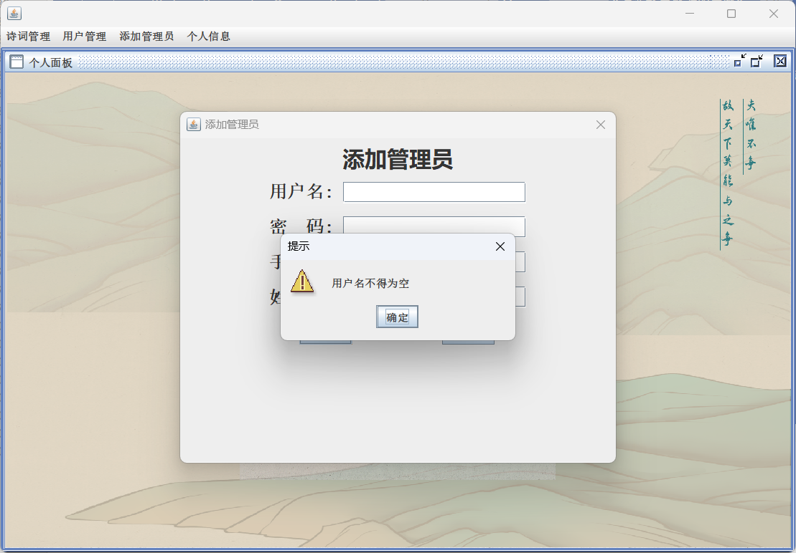

图2.9.1 提示用户名不得为空

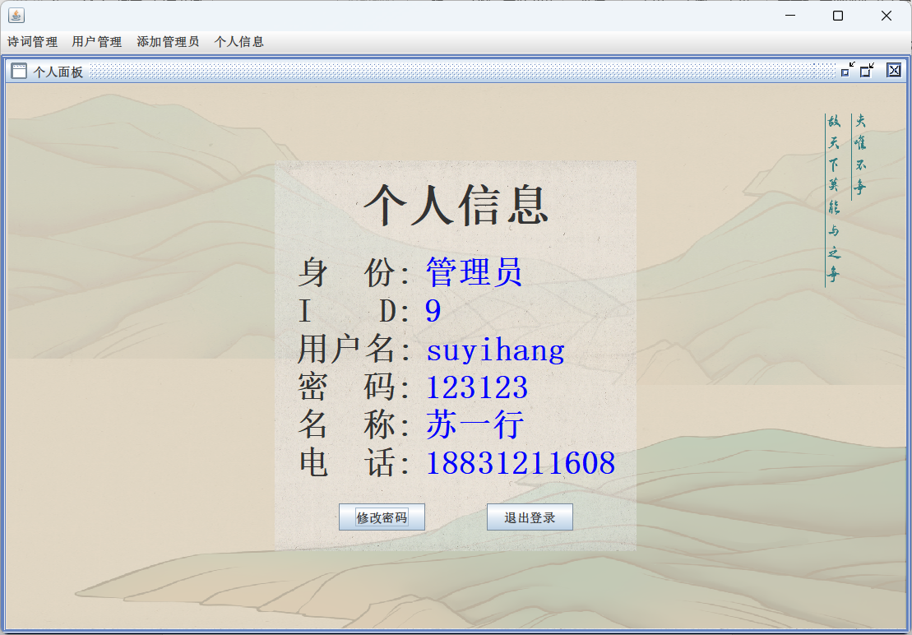

图2.9.2 个人信息

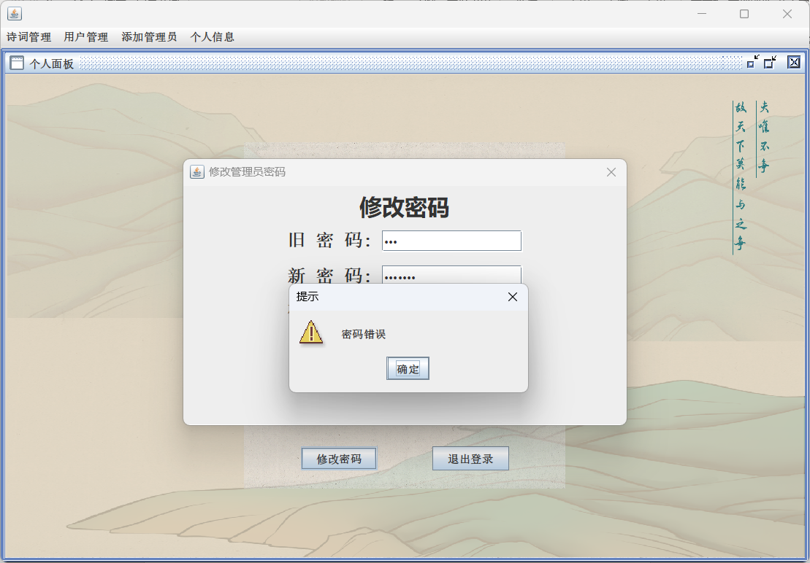

图2.9.3 提示密码错误

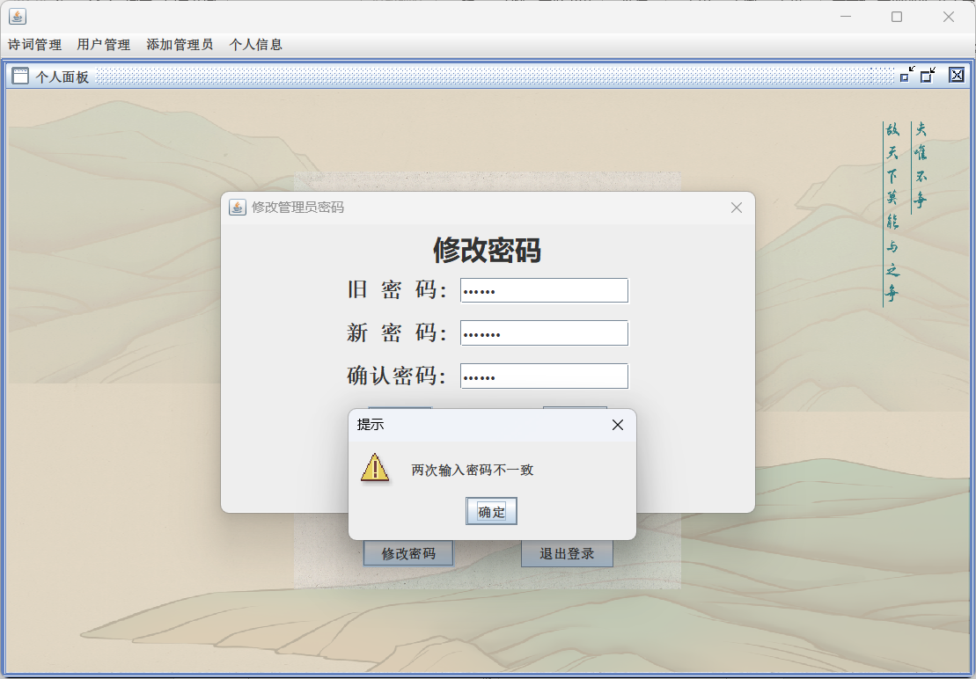

图2.9.4 提示两次输入密码不一致

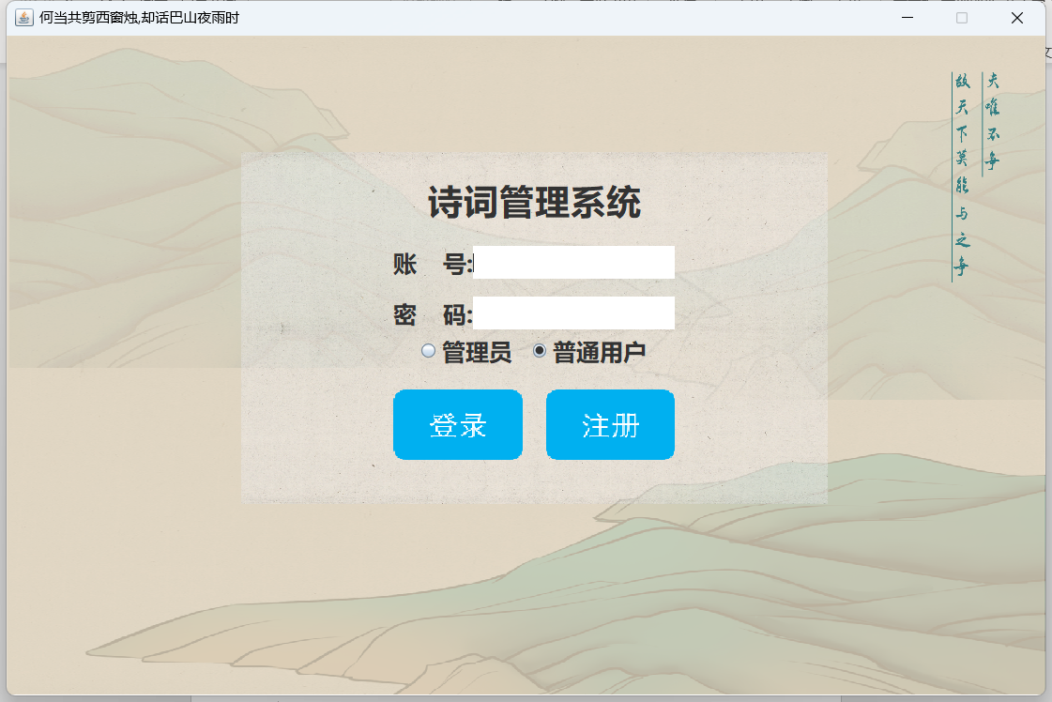

图2.9.5 单击退出登录返回登录界面

1. 代码实现：

添加管理员：

**package** frame.admin.Dialog;  
  
**import** database.DataInsert;  
  
**import** javax.swing.*;  
**import** java.awt.*;  
**import** java.awt.event.MouseAdapter;  
**import** java.awt.event.MouseEvent;  
  
**public class** AddAdminDialog **extends** JDialog {  
 **public** AddAdminDialog(Frame owner) {  
 **super**(owner, **"添加管理员"**, **true**); *// true 表示模态对话框* initDialog();  
 }  
  
 JTextField **userNameField**;  
 JTextField **userField**;  
 JTextField **passwordField**;  
 JTextField **telephoneField**;  
  
 **private void** initDialog() {  
  
 *// 设置对话框的大小* **this**.setSize(500, 400);  
  
 *// 获取屏幕大小* Dimension screenSize = Toolkit.*getDefaultToolkit*().getScreenSize();  
 *// 计算对话框应居中的位置* **int** x = (screenSize.**width** - **this**.getWidth()) / 2;  
 **int** y = (screenSize.**height** - **this**.getHeight()) / 2;  
 *// 设置对话框的位置* **this**.setLocation(x, y);  
  
 JPanel south = **new** JPanel();  
 JLabel southLabel = **new** JLabel(**"添加管理员"**);  
 Font font = **new** Font(**"微软雅黑"**, Font.***BOLD***, 25);  
 southLabel.setFont(font);  
 south.add(southLabel);  
 **this**.add(south, BorderLayout.***NORTH***);  
  
 JPanel jPanel = **new** JPanel();  
  
 Box box = Box.*createVerticalBox*();  
 Font boxFont = **new** Font(**"宋体"**, Font.***BOLD***, 20);  
  
 *// 添加标题* Box box1 = Box.*createHorizontalBox*();  
 JLabel titleLabel = **new** JLabel(**"用户名:"**);  
 titleLabel.setFont(boxFont);  
 **userField** = **new** JTextField(20);  
 box1.add(titleLabel);  
 box1.add(Box.*createHorizontalStrut*(10));  
 box1.add(**userField**);  
 box.add(box1);  
 box.add(Box.*createVerticalStrut*(15));  
  
 *// 添加作者* Box box2 = Box.*createHorizontalBox*();  
 JLabel passLabel = **new** JLabel(**"密 码:"**);  
 passLabel.setFont(boxFont);  
 **passwordField** = **new** JTextField(20);  
 box2.add(passLabel);  
 box2.add(Box.*createHorizontalStrut*(10));  
 box2.add(**passwordField**);  
 box.add(box2);  
 box.add(Box.*createVerticalStrut*(15));  
  
 Box box3 = Box.*createHorizontalBox*();  
 JLabel telLabel = **new** JLabel(**"手机号:"**);  
 telLabel.setFont(boxFont);  
 **telephoneField** = **new** JTextField(20);  
 box3.add(telLabel);  
 box3.add(Box.*createHorizontalStrut*(10));  
 box3.add(**telephoneField**);  
 box.add(box3);  
 box.add(Box.*createVerticalStrut*(15));  
  
  
 Box box4 = Box.*createHorizontalBox*();  
 JLabel nameLabel = **new** JLabel(**"姓 名:"**);  
 nameLabel.setFont(boxFont);  
 **userNameField** = **new** JTextField(20);  
 box4.add(nameLabel);  
 box4.add(Box.*createHorizontalStrut*(10));  
 box4.add(**userNameField**);  
 box.add(box4);  
 box.add(Box.*createVerticalStrut*(15));  
  
 Box boxButton = Box.*createHorizontalBox*();  
 JButton addBut = **new** JButton(**"添加"**);  
 JButton clearBut = **new** JButton(**"清空"**);  
  
 addBut.addMouseListener(**new** MouseAdapter() {  
 @Override  
 **public void** mouseClicked(MouseEvent e) {  
 addAdmin();  
 }  
 });  
  
 clearBut.addMouseListener(**new** MouseAdapter() {  
 @Override  
 **public void** mouseClicked(MouseEvent e) {  
 clearText();  
 }  
 });  
  
 boxButton.add(addBut);  
 boxButton.add(Box.*createHorizontalStrut*(100));  
 boxButton.add(clearBut);  
  
 box.add(boxButton);  
  
 jPanel.add(box, BorderLayout.***CENTER***);  
  
 **this**.add(jPanel, BorderLayout.***CENTER***);  
  
 *// 设置对话框的默认关闭操作* **this**.setDefaultCloseOperation(JDialog.***DISPOSE_ON_CLOSE***);  
 }  
  
 **private void** addAdmin(){  
 String user = **userField**.getText().trim();  
 String pass = **passwordField**.getText().trim();  
 String tel = **telephoneField**.getText().trim();  
 String name = **userNameField**.getText().trim();  
  
 **if** (user.isEmpty()) {  
 JOptionPane.*showMessageDialog*(**this**, **"用户名不得为空"**, **"提示"**, JOptionPane.***WARNING_MESSAGE***);  
 **return**;  
 }  
 **if** (pass.isEmpty()) {  
 JOptionPane.*showMessageDialog*(**this**, **"密码不得为空"**, **"提示"**, JOptionPane.***WARNING_MESSAGE***);  
 **return**;  
 }  
 **if** (DataInsert.*AdminInsert*(user, pass, name, tel)){  
 JOptionPane.*showMessageDialog*(**this**, **"添加成功"**, **"提示"**, JOptionPane.***WARNING_MESSAGE***);  
 } **else** {  
 JOptionPane.*showMessageDialog*(**this**, **"用户名重复"**, **"提示"**, JOptionPane.***WARNING_MESSAGE***);  
 }  
 }  
  
 **private void** clearText(){  
 **userField**.setText(**""**);  
 **passwordField**.setText(**""**);  
 **telephoneField**.setText(**""**);  
 **userNameField**.setText(**""**);  
 }  
}

个人面板：

**public class** adminPersonalPanel **extends** JInternalFrame {  
  
 **public** adminPersonalPanel() {  
 **super**(**"个人面板"**, **true**, **true**, **true**, **true**);  
 initCenter();  
 **try** {  
 setMaximum(**true**);  
 } **catch** (PropertyVetoException e) {  
 e.printStackTrace();  
 }  
 }  
  
 **private void** initCenter() {  
 JPanel center = **new** JPanel() {  
 @Override  
 **protected void** paintComponent(Graphics g) {  
 Graphics2D g2 = (Graphics2D) g;  
 g2.drawImage(**new** ImageIcon(SystemConstants.***dir*** + **"bg1.png"**).getImage(), 0, 0, getWidth(), getHeight(), **null**);  
 }  
 };  
 center.setLayout(**new** GridBagLayout()); *// 使用GridBagLayout居中* JPanel panel = **new** JPanel() {  
 @Override  
 **protected void** paintComponent(Graphics g) {  
 Graphics2D g2 = (Graphics2D) g;  
 g2.drawImage(**new** ImageIcon(SystemConstants.***dir*** + **"001.png"**).getImage(), 0, 0, getWidth(), getHeight(), **null**);  
 }  
 };  
 panel.setOpaque(**false**);  
 panel.setLayout(**new** BoxLayout(panel, BoxLayout.***Y_AXIS***)); *// 使用BoxLayout垂直排列* Administrator admin = DataSelece.*findByAdminID*(SystemConstants.*currentID*);  
 **assert** admin != **null**;  
  
 Box box = Box.*createVerticalBox*();  
 box.setBorder(BorderFactory.*createEmptyBorder*(20, 20, 20, 20));  
  
 Font labelFont = **new** Font(**"宋体"**, Font.***BOLD***, 32);  
 Font valueFont = **new** Font(**"宋体"**, Font.***BOLD***, 32);  
  
 JLabel title = **new** JLabel(**"个人信息"**);  
 title.setFont(**new** Font(**"宋体"**, Font.***BOLD***, 45));  
 title.setAlignmentX(Component.***CENTER_ALIGNMENT***); *// 标题居中对齐* box.add(title);  
 box.add(Box.*createVerticalStrut*(20));  
 box.add(createBox(**"身 份:"**, **"管理员"**, labelFont, valueFont));  
 box.add(createBox(**"I D:"**, String.*valueOf*(admin.getId()), labelFont, valueFont));  
 box.add(createBox(**"用户名:"**, admin.getAccount(), labelFont, valueFont));  
 box.add(createBox(**"密 码:"**, admin.getPassword(), labelFont, valueFont));  
 box.add(createBox(**"名 称:"**, admin.getName(), labelFont, valueFont));  
 box.add(createBox(**"电 话:"**, admin.getTelephone(), labelFont, valueFont));  
 box.add(Box.*createVerticalStrut*(20));  
 Box boxBtu = Box.*createHorizontalBox*();  
 JButton change = **new** JButton(**"修改密码"**);  
 JButton logOut = **new** JButton(**"退出登录"**);  
  
 logOut.addMouseListener(**new** MouseAdapter() {  
 @Override  
 **public void** mouseClicked(MouseEvent e) {  
 logout();  
 }  
 });  
  
 change.addMouseListener(**new** MouseAdapter() {  
 @Override  
 **public void** mouseClicked(MouseEvent e) {  
 **new** ModifyAdminPasswordDialog(getParentJFrame(), SystemConstants.*currentID*).setVisible(**true**);  
  
 }  
 });  
  
 boxBtu.add(change);  
 boxBtu.add(Box.*createHorizontalStrut*(60));  
 boxBtu.add(logOut);  
  
 box.add(boxBtu);  
 panel.add(box);  
  
 GridBagConstraints gbc = **new** GridBagConstraints();  
 gbc.**gridx** = 0;  
 gbc.**gridy** = 0;  
 gbc.**anchor** = GridBagConstraints.***CENTER***;  
 center.add(panel, gbc);  
  
 **this**.add(center);  
 }  
  
 **private** Box createBox(String labelText, String valueText, Font labelFont, Font valueFont) {  
 Box box = Box.*createHorizontalBox*();  
 JLabel label = **new** JLabel(labelText);  
 label.setFont(labelFont);  
 JLabel value = **new** JLabel(valueText);  
 value.setFont(valueFont);  
 value.setForeground(Color.***BLUE***);  
 box.add(label);  
 box.add(Box.*createHorizontalStrut*(10)); *// 添加一个水平间隔* box.add(value);  
 box.add(Box.*createVerticalStrut*(20)); *// 添加一个垂直间隔* **return** box;  
 }  
  
 *// 退出登录* **private void** logout() {  
 SwingUtilities.*getWindowAncestor*(**this**).dispose(); *// 关闭当前窗口* JFrame mainFrame = **new** MainFrame(); *// 创建 MainFrame 界面* mainFrame.setVisible(**true**); *// 显示 MainFrame 界面* }  
 *// 获取当前页面所从属的JFrame面板* **private** JFrame getParentJFrame() {  
 Container parent = **this**.getParent();  
 **while** (parent != **null**) {  
 **if** (parent **instanceof** JFrame) {  
 **return** (JFrame) parent;  
 }  
 parent = parent.getParent();  
 }  
 **return null**;  
 }  
}